**Bootstrap**

* **Quick start :**

Basic code for bootstrap

* Output :

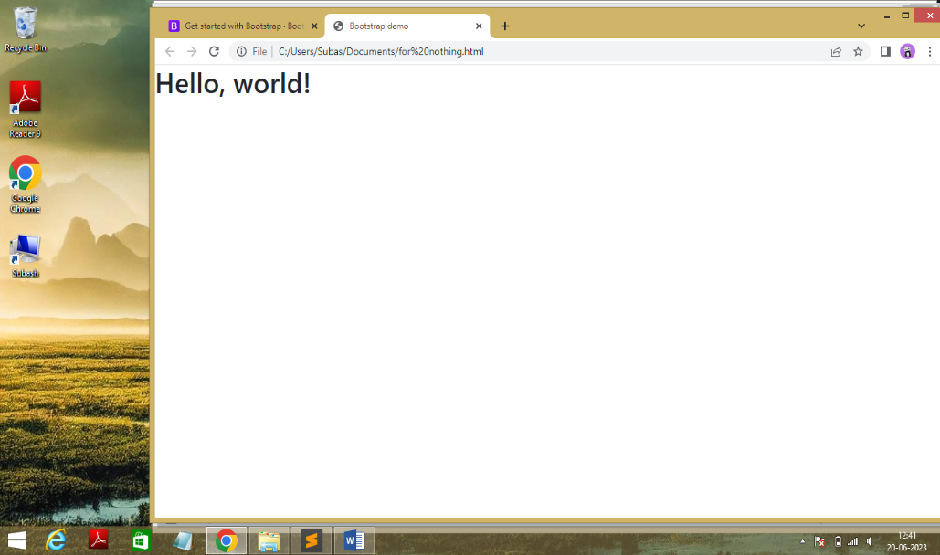

* Code:

<!doctype html>

<html lang="en">

<head>

<meta charset="utf-8">

<meta name="viewport" content="width=device-width, initial-scale=1">

<title>Bootstrap demo</title>

<link href="https://cdn.jsdelivr.net/npm/bootstrap@5.3.0/dist/css/bootstrap.min.css" rel="stylesheet" integrity="sha384-9ndCyUaIbzAi2FUVXJi0CjmCapSmO7SnpJef0486qhLnuZ2cdeRhO02iuK6FUUVM" crossorigin="anonymous">

</head>

<body>

<h1>Hello, world!</h1>

<script src="https://cdn.jsdelivr.net/npm/bootstrap@5.3.0/dist/js/bootstrap.bundle.min.js" integrity="sha384-geWF76RCwLtnZ8qwWowPQNguL3RmwHVBC9FhGdlKrxdiJJigb/j/68SIy3Te4Bkz" crossorigin="anonymous"></script>

</body>

</html>

* List of Components :
  + - Buttons
    - Alert
    - Card
    - Carousel
    - Form control
    - Select
    - Radio and checkbox
    - Table
    - Toasts
    - Modal
    - Progress bar
    - Navbar
    - Spinner
* **Buttons :**

* **Button variants :**
* Output **:**

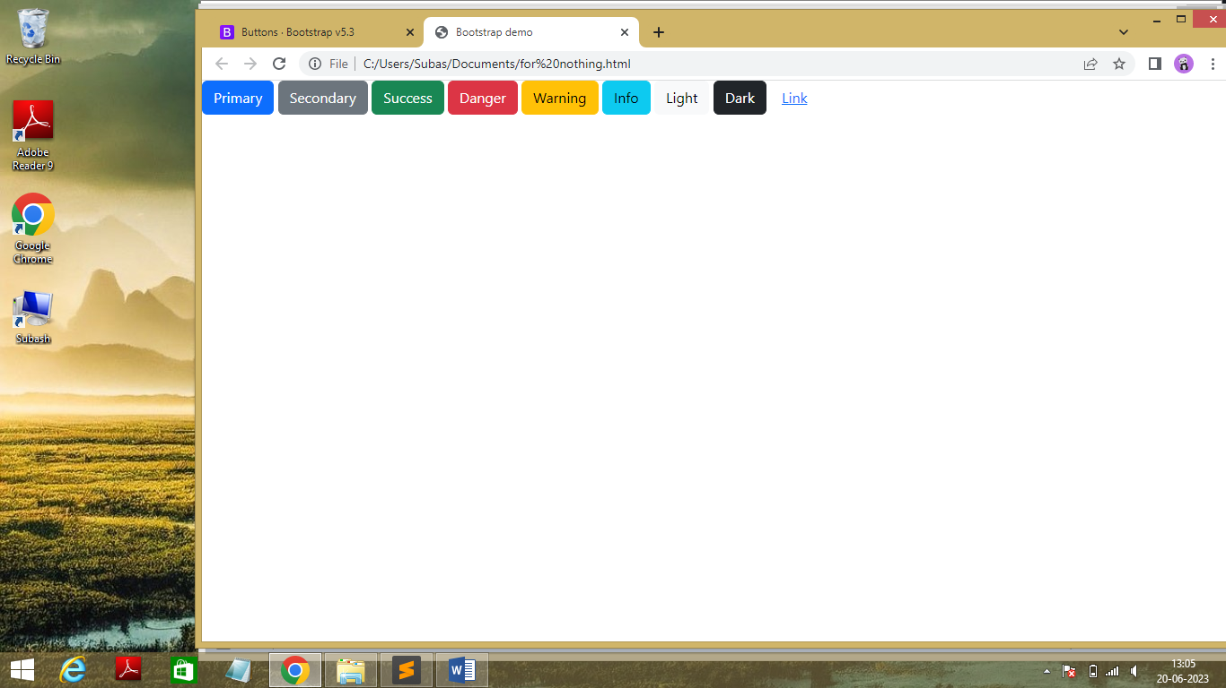

* Code :

<!doctype html>

<html lang="en">

<head>

<meta charset="utf-8">

<meta name="viewport" content="width=device-width, initial-scale=1">

<title>Bootstrap demo</title>

<link href="https://cdn.jsdelivr.net/npm/bootstrap@5.3.0/dist/css/bootstrap.min.css" rel="stylesheet" integrity="sha384-9ndCyUaIbzAi2FUVXJi0CjmCapSmO7SnpJef0486qhLnuZ2cdeRhO02iuK6FUUVM" crossorigin="anonymous">

</head>

<body>

<button type="button" class="btn btn-primary">Primary</button>

<button type="button" class="btn btn-secondary">Secondary</button>

<button type="button" class="btn btn-success">Success</button>

<button type="button" class="btn btn-danger">Danger</button>

<button type="button" class="btn btn-warning">Warning</button>

<button type="button" class="btn btn-info">Info</button>

<button type="button" class="btn btn-light">Light</button>

<button type="button" class="btn btn-dark">Dark</button>

<button type="button" class="btn btn-link">Link</button>

<script src="https://cdn.jsdelivr.net/npm/bootstrap@5.3.0/dist/js/bootstrap.bundle.min.js" integrity="sha384-geWF76RCwLtnZ8qwWowPQNguL3RmwHVBC9FhGdlKrxdiJJigb/j/68SIy3Te4Bkz" crossorigin="anonymous"></script>

</body>

</html>

* + **Outline Buttons :**
* Output **:**

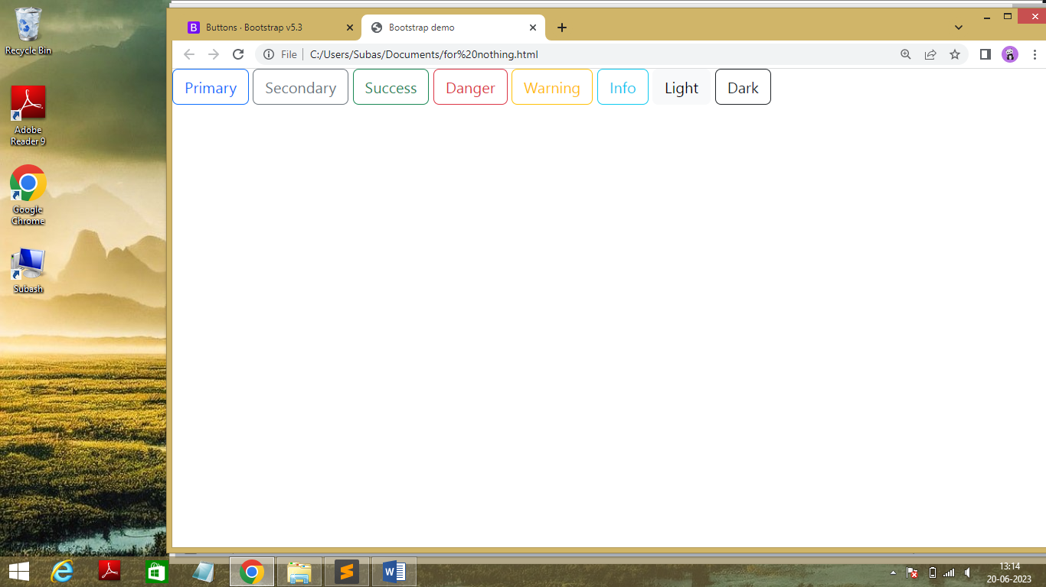

* Code :

<!doctype html>

<html lang="en">

<head>

<meta charset="utf-8">

<meta name="viewport" content="width=device-width, initial-scale=1">

<title>Bootstrap demo</title>

<link href="https://cdn.jsdelivr.net/npm/bootstrap@5.3.0/dist/css/bootstrap.min.css" rel="stylesheet" integrity="sha384-9ndCyUaIbzAi2FUVXJi0CjmCapSmO7SnpJef0486qhLnuZ2cdeRhO02iuK6FUUVM" crossorigin="anonymous">

</head>

<body>

<button type="button" class="btn btn-outline-primary">Primary</button>

<button type="button" class="btn btn-outline-secondary">Secondary</button>

<button type="button" class="btn btn-outline-success">Success</button>

<button type="button" class="btn btn-outline-danger">Danger</button>

<button type="button" class="btn btn-outline-warning">Warning</button>

<button type="button" class="btn btn-outline-info">Info</button>

<button type="button" class="btn btn-outline-light">Light</button>

<button type="button" class="btn btn-outline-dark">Dark</button>

<script src="https://cdn.jsdelivr.net/npm/bootstrap@5.3.0/dist/js/bootstrap.bundle.min.js" integrity="sha384-geWF76RCwLtnZ8qwWowPQNguL3RmwHVBC9FhGdlKrxdiJJigb/j/68SIy3Te4Bkz" crossorigin="anonymous"></script>

</body>

</html>\

* + **Sizing and Disabled Buttons**
* Output :

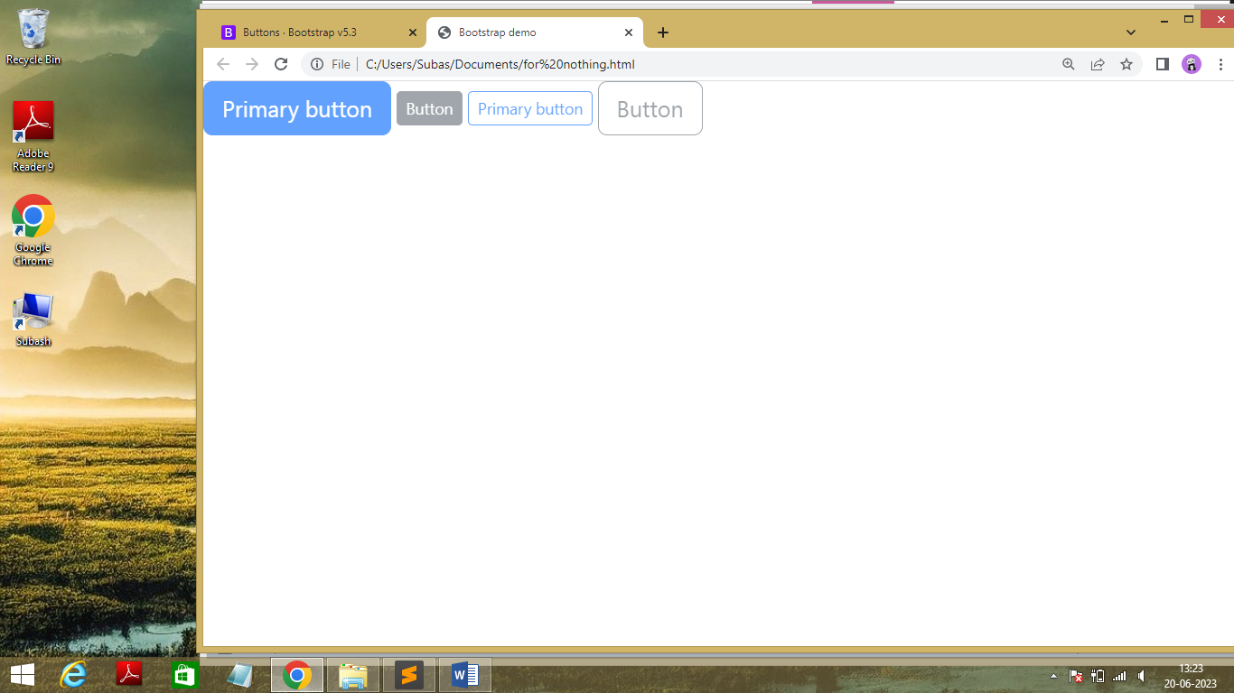

* Code :

<!doctype html>

<html lang="en">

<head>

<meta charset="utf-8">

<meta name="viewport" content="width=device-width, initial-scale=1">

<title>Bootstrap demo</title>

<link href="https://cdn.jsdelivr.net/npm/bootstrap@5.3.0/dist/css/bootstrap.min.css" rel="stylesheet" integrity="sha384-9ndCyUaIbzAi2FUVXJi0CjmCapSmO7SnpJef0486qhLnuZ2cdeRhO02iuK6FUUVM" crossorigin="anonymous">

</head>

<body>

<button type="button" class="btn btn-primary btn-lg"disabled>Primary button</button>

<button type="button" class="btn btn-secondary btn-sm" disabled>Button</button>

<button type="button" class="btn btn-outline-primary btn-sm" disabled>Primary button</button>

<button type="button" class="btn btn-outline-secondary btn-lg" disabled>Button</button>

<script src="https://cdn.jsdelivr.net/npm/bootstrap@5.3.0/dist/js/bootstrap.bundle.min.js" integrity="sha384-geWF76RCwLtnZ8qwWowPQNguL3RmwHVBC9FhGdlKrxdiJJigb/j/68SIy3Te4Bkz" crossorigin="anonymous"></script>

</body>

</html>

* + - * **Alerts**
* **Alert variants**
* Output :

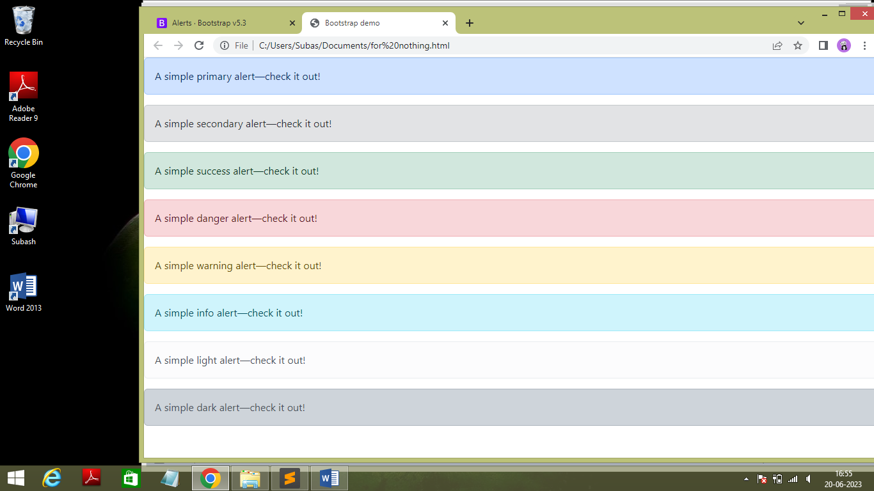

* Code :

<!doctype html>

<html lang="en">

<head>

<meta charset="utf-8">

<meta name="viewport" content="width=device-width, initial-scale=1">

<title>Bootstrap demo</title>

<link href="https://cdn.jsdelivr.net/npm/bootstrap@5.3.0/dist/css/bootstrap.min.css" rel="stylesheet" integrity="sha384-9ndCyUaIbzAi2FUVXJi0CjmCapSmO7SnpJef0486qhLnuZ2cdeRhO02iuK6FUUVM" crossorigin="anonymous">

</head>

<body>

<div class="alert alert-primary" role="alert">

A simple primary alert—check it out!

</div>

<div class="alert alert-secondary" role="alert">

A simple secondary alert—check it out!

</div>

<div class="alert alert-success" role="alert">

A simple success alert—check it out!

</div>

<div class="alert alert-danger" role="alert">

A simple danger alert—check it out!

</div>

<div class="alert alert-warning" role="alert">

A simple warning alert—check it out!

</div>

<div class="alert alert-info" role="alert">

A simple info alert—check it out!

</div>

<div class="alert alert-light" role="alert">

A simple light alert—check it out!

</div>

<div class="alert alert-dark" role="alert">

A simple dark alert—check it out!

</div>

<script src="https://cdn.jsdelivr.net/npm/bootstrap@5.3.0/dist/js/bootstrap.bundle.min.js" integrity="sha384-geWF76RCwLtnZ8qwWowPQNguL3RmwHVBC9FhGdlKrxdiJJigb/j/68SIy3Te4Bkz" crossorigin="anonymous"></script>

</body>

</html>

* **Additional content**
* Output :

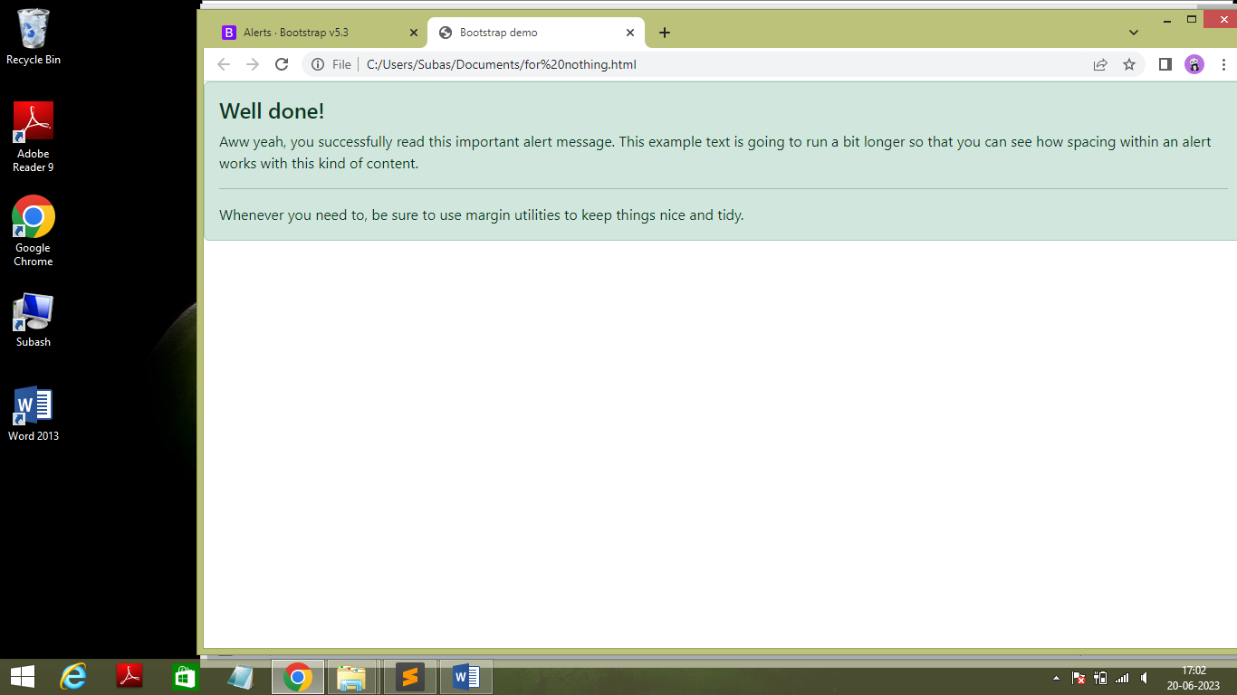

* Code :

<!doctype html>

<html lang="en">

<head>

<meta charset="utf-8">

<meta name="viewport" content="width=device-width, initial-scale=1">

<title>Bootstrap demo</title>

<link href="https://cdn.jsdelivr.net/npm/bootstrap@5.3.0/dist/css/bootstrap.min.css" rel="stylesheet" integrity="sha384-9ndCyUaIbzAi2FUVXJi0CjmCapSmO7SnpJef0486qhLnuZ2cdeRhO02iuK6FUUVM" crossorigin="anonymous">

</head>

<body>

<div class="alert alert-success" role="alert">

<h4 class="alert-heading">Well done!</h4>

<p>Aww yeah, you successfully read this important alert message. This example text is going to run a bit longer so that you can see how spacing within an alert works with this kind of content.</p>

<hr>

<p class="mb-0">Whenever you need to, be sure to use margin utilities to keep things nice and tidy.</p>

</div>

<script src="https://cdn.jsdelivr.net/npm/bootstrap@5.3.0/dist/js/bootstrap.bundle.min.js" integrity="sha384-geWF76RCwLtnZ8qwWowPQNguL3RmwHVBC9FhGdlKrxdiJJigb/j/68SIy3Te4Bkz" crossorigin="anonymous"></script>

</body>

</html>

* **Alert with Icon**
* Output **:**

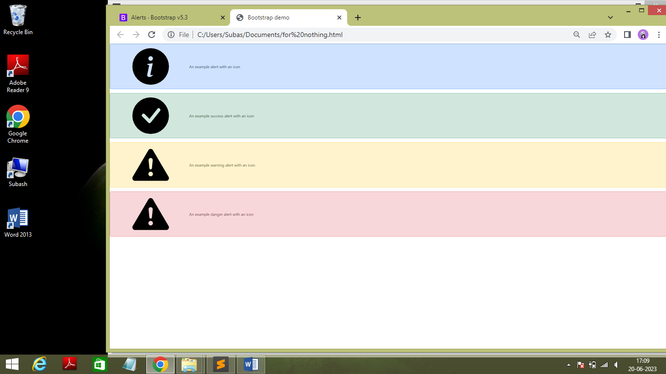

* Code :

<!doctype html>

<html lang="en">

<head>

<meta charset="utf-8">

<meta name="viewport" content="width=device-width, initial-scale=1">

<title>Bootstrap demo</title>

<link href="https://cdn.jsdelivr.net/npm/bootstrap@5.3.0/dist/css/bootstrap.min.css" rel="stylesheet" integrity="sha384-9ndCyUaIbzAi2FUVXJi0CjmCapSmO7SnpJef0486qhLnuZ2cdeRhO02iuK6FUUVM" crossorigin="anonymous">

</head>

<body>

<svg xmlns="http://www.w3.org/2000/svg" style="display: none;">

<symbol id="check-circle-fill" viewBox="0 0 16 16">

<path d="M16 8A8 8 0 1 1 0 8a8 8 0 0 1 16 0zm-3.97-3.03a.75.75 0 0 0-1.08.022L7.477 9.417 5.384 7.323a.75.75 0 0 0-1.06 1.06L6.97 11.03a.75.75 0 0 0 1.079-.02l3.992-4.99a.75.75 0 0 0-.01-1.05z"/>

</symbol>

<symbol id="info-fill" viewBox="0 0 16 16">

<path d="M8 16A8 8 0 1 0 8 0a8 8 0 0 0 0 16zm.93-9.412-1 4.705c-.07.34.029.533.304.533.194 0 .487-.07.686-.246l-.088.416c-.287.346-.92.598-1.465.598-.703 0-1.002-.422-.808-1.319l.738-3.468c.064-.293.006-.399-.287-.47l-.451-.081.082-.381 2.29-.287zM8 5.5a1 1 0 1 1 0-2 1 1 0 0 1 0 2z"/>

</symbol>

<symbol id="exclamation-triangle-fill" viewBox="0 0 16 16">

<path d="M8.982 1.566a1.13 1.13 0 0 0-1.96 0L.165 13.233c-.457.778.091 1.767.98 1.767h13.713c.889 0 1.438-.99.98-1.767L8.982 1.566zM8 5c.535 0 .954.462.9.995l-.35 3.507a.552.552 0 0 1-1.1 0L7.1 5.995A.905.905 0 0 1 8 5zm.002 6a1 1 0 1 1 0 2 1 1 0 0 1 0-2z"/>

</symbol>

</svg>

<div class="alert alert-primary d-flex align-items-center" role="alert">

<svg class="bi flex-shrink-0 me-2" role="img" aria-label="Info:"><use xlink:href="#info-fill"/></svg>

<div>

An example alert with an icon

</div>

</div>

<div class="alert alert-success d-flex align-items-center" role="alert">

<svg class="bi flex-shrink-0 me-2" role="img" aria-label="Success:"><use xlink:href="#check-circle-fill"/></svg>

<div>

An example success alert with an icon

</div>

</div>

<div class="alert alert-warning d-flex align-items-center" role="alert">

<svg class="bi flex-shrink-0 me-2" role="img" aria-label="Warning:"><use xlink:href="#exclamation-triangle-fill"/></svg>

<div>

An example warning alert with an icon

</div>

</div>

<div class="alert alert-danger d-flex align-items-center" role="alert">

<svg class="bi flex-shrink-0 me-2" role="img" aria-label="Danger:"><use xlink:href="#exclamation-triangle-fill"/></svg>

<div>

An example danger alert with an icon

</div>

</div>

<script src="https://cdn.jsdelivr.net/npm/bootstrap@5.3.0/dist/js/bootstrap.bundle.min.js" integrity="sha384-geWF76RCwLtnZ8qwWowPQNguL3RmwHVBC9FhGdlKrxdiJJigb/j/68SIy3Te4Bkz" crossorigin="anonymous"></script>

</body>

</html>

* **Dismissing The Alert**
* Output **:**

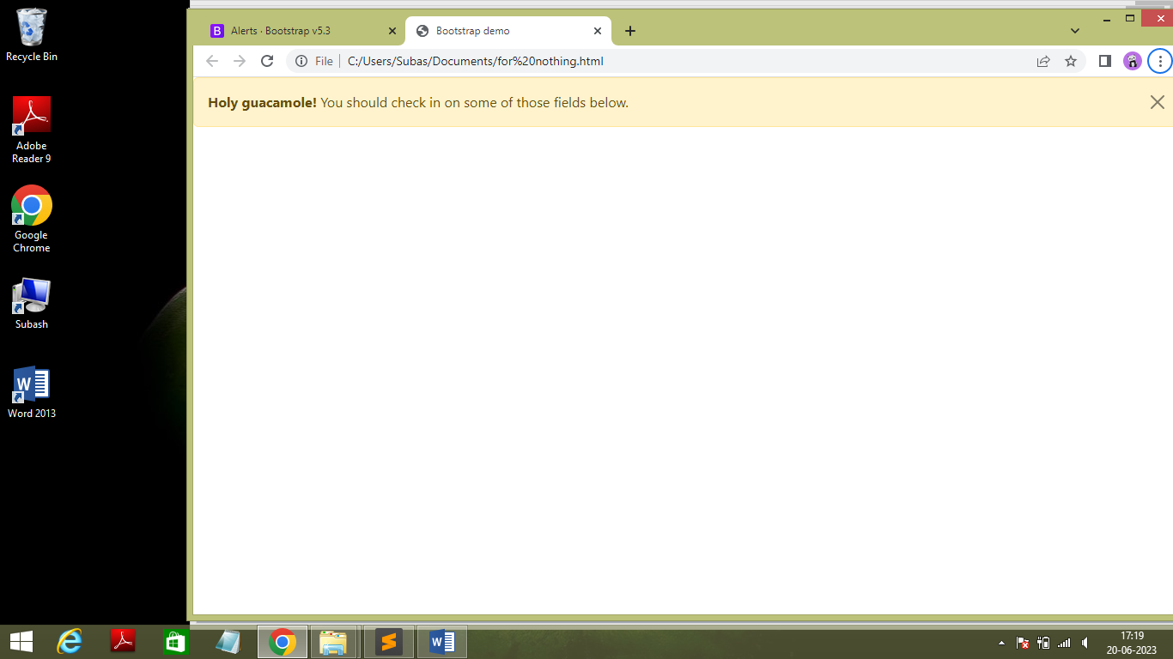

* Code :

<!doctype html>

<html lang="en">

<head>

<meta charset="utf-8">

<meta name="viewport" content="width=device-width, initial-scale=1">

<title>Bootstrap demo</title>

<link href="https://cdn.jsdelivr.net/npm/bootstrap@5.3.0/dist/css/bootstrap.min.css" rel="stylesheet" integrity="sha384-9ndCyUaIbzAi2FUVXJi0CjmCapSmO7SnpJef0486qhLnuZ2cdeRhO02iuK6FUUVM" crossorigin="anonymous">

</head>

<body>

<div class="alert alert-warning alert-dismissible fade show" role="alert">

<strong>Holy guacamole!</strong> You should check in on some of those fields below.

<button type="button" class="btn-close" data-bs-dismiss="alert" aria-label="Close"></button>

</div>

<script src="https://cdn.jsdelivr.net/npm/bootstrap@5.3.0/dist/js/bootstrap.bundle.min.js" integrity="sha384-geWF76RCwLtnZ8qwWowPQNguL3RmwHVBC9FhGdlKrxdiJJigb/j/68SIy3Te4Bkz" crossorigin="anonymous"></script>

</body>

</html>

* + - * **Card**
* **Content in Cards**

An example with card title,body,text,link and image

* Output :

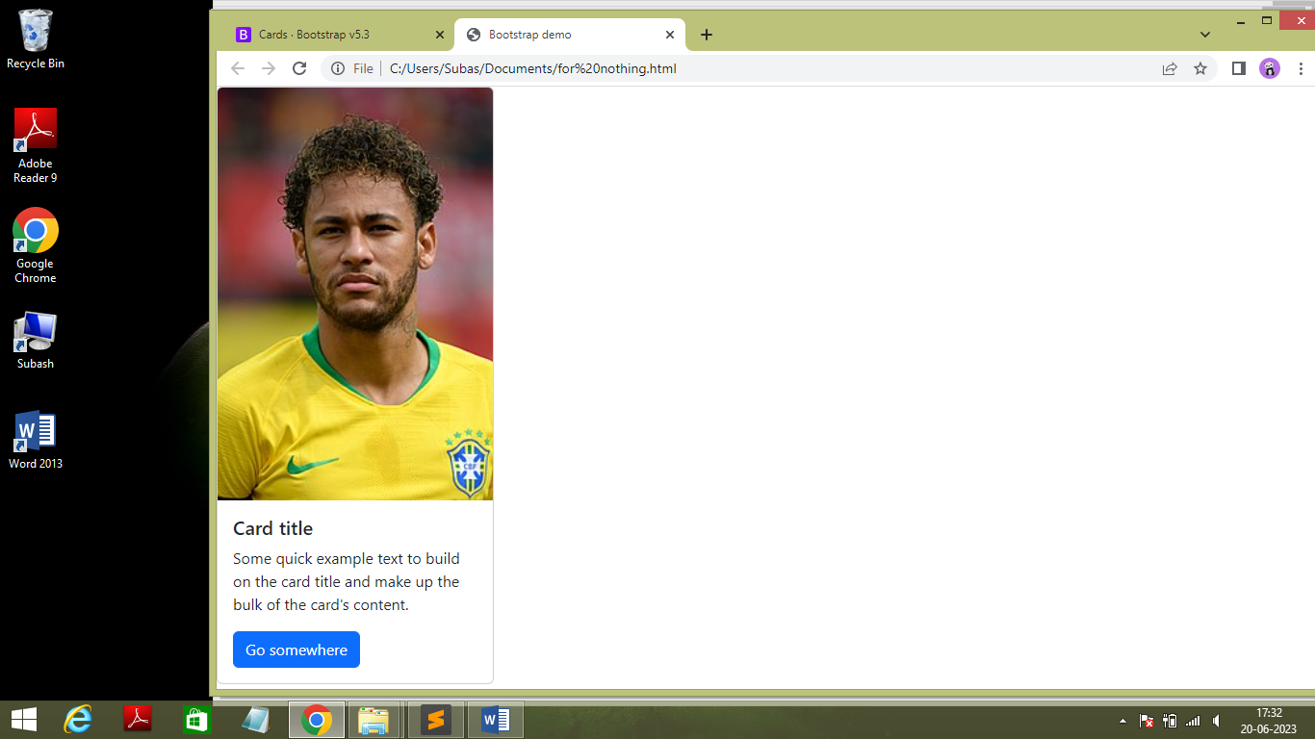

* Code :

<!doctype html>

<html lang="en">

<head>

<meta charset="utf-8">

<meta name="viewport" content="width=device-width, initial-scale=1">

<title>Bootstrap demo</title>

<link href="https://cdn.jsdelivr.net/npm/bootstrap@5.3.0/dist/css/bootstrap.min.css" rel="stylesheet" integrity="sha384-9ndCyUaIbzAi2FUVXJi0CjmCapSmO7SnpJef0486qhLnuZ2cdeRhO02iuK6FUUVM" crossorigin="anonymous">

</head>

<body>

<div class="card" style="width: 18rem;">

<img src="https://upload.wikimedia.org/wikipedia/commons/thumb/6/65/20180610_FIFA_Friendly_Match_Austria_vs._Brazil_Neymar_850_1705.jpg/220px-20180610_FIFA_Friendly_Match_Austria_vs._Brazil_Neymar_850_1705.jpg" class="card-img-top" alt="Neymar">

<div class="card-body">

<h5 class="card-title">Card title</h5>

<p class="card-text">Some quick example text to build on the card title and make up the bulk of the card's content.</p>

<a href="#" class="btn btn-primary">Go somewhere</a>

</div>

</div>

<script src="https://cdn.jsdelivr.net/npm/bootstrap@5.3.0/dist/js/bootstrap.bundle.min.js" integrity="sha384-geWF76RCwLtnZ8qwWowPQNguL3RmwHVBC9FhGdlKrxdiJJigb/j/68SIy3Te4Bkz" crossorigin="anonymous"></script>

</body>

</html>

* **Sizing**
* Output **:**

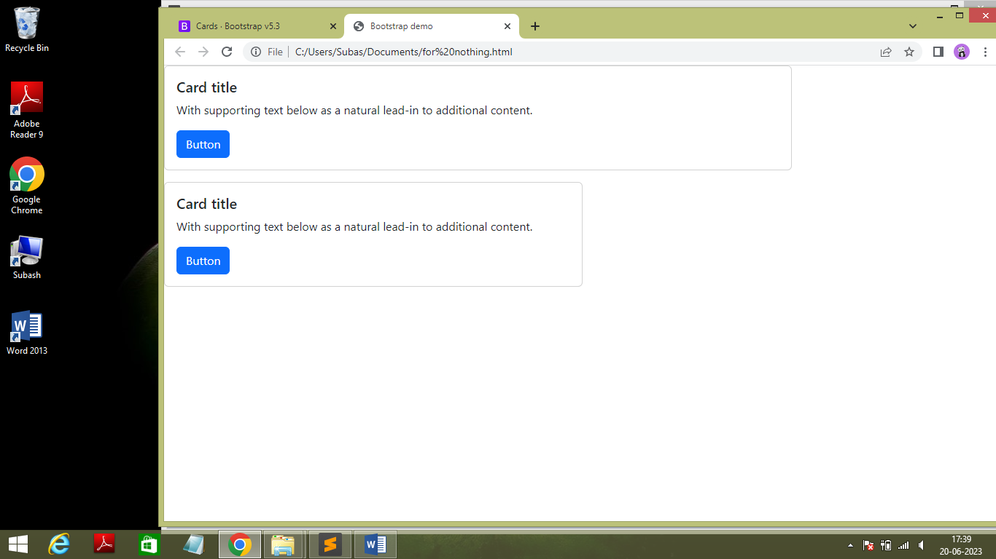

* Code :

<!doctype html>

<html lang="en">

<head>

<meta charset="utf-8">

<meta name="viewport" content="width=device-width, initial-scale=1">

<title>Bootstrap demo</title>

<link href="https://cdn.jsdelivr.net/npm/bootstrap@5.3.0/dist/css/bootstrap.min.css" rel="stylesheet" integrity="sha384-9ndCyUaIbzAi2FUVXJi0CjmCapSmO7SnpJef0486qhLnuZ2cdeRhO02iuK6FUUVM" crossorigin="anonymous">

</head>

<body>

<div class="card w-75 mb-3">

<div class="card-body">

<h5 class="card-title">Card title</h5>

<p class="card-text">With supporting text below as a natural lead-in to additional content.</p>

<a href="#" class="btn btn-primary">Button</a>

</div>

</div>

<div class="card w-50">

<div class="card-body">

<h5 class="card-title">Card title</h5>

<p class="card-text">With supporting text below as a natural lead-in to additional content.</p>

<a href="#" class="btn btn-primary">Button</a>

</div>

</div>

<script src="https://cdn.jsdelivr.net/npm/bootstrap@5.3.0/dist/js/bootstrap.bundle.min.js" integrity="sha384-geWF76RCwLtnZ8qwWowPQNguL3RmwHVBC9FhGdlKrxdiJJigb/j/68SIy3Te4Bkz" crossorigin="anonymous"></script>

</body>

</html>

* **Text Alignment**
* Output :

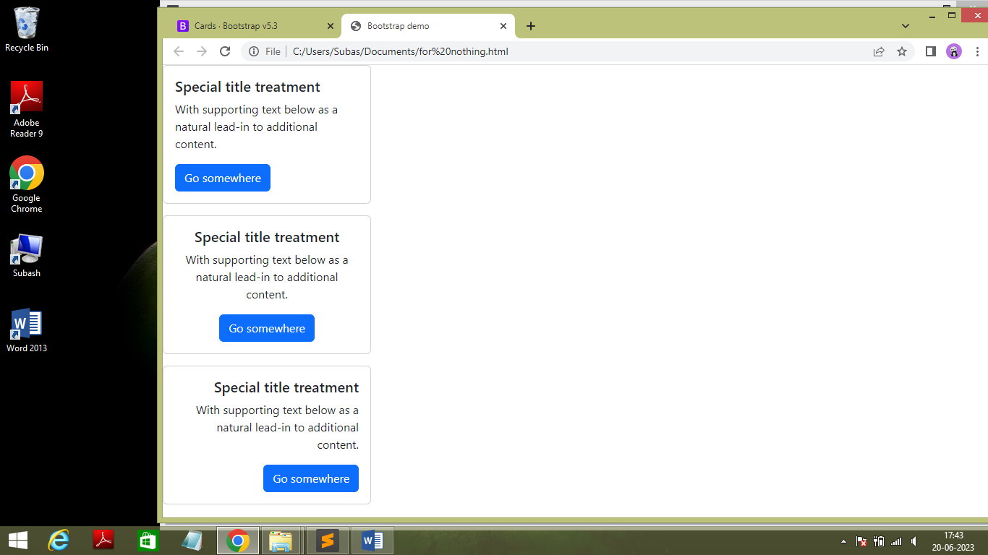

* Code :

<!doctype html>

<html lang="en">

<head>

<meta charset="utf-8">

<meta name="viewport" content="width=device-width, initial-scale=1">

<title>Bootstrap demo</title>

<link href="https://cdn.jsdelivr.net/npm/bootstrap@5.3.0/dist/css/bootstrap.min.css" rel="stylesheet" integrity="sha384-9ndCyUaIbzAi2FUVXJi0CjmCapSmO7SnpJef0486qhLnuZ2cdeRhO02iuK6FUUVM" crossorigin="anonymous">

</head>

<body>

<div class="card mb-3" style="width: 18rem;">

<div class="card-body">

<h5 class="card-title">Special title treatment</h5>

<p class="card-text">With supporting text below as a natural lead-in to additional content.</p>

<a href="#" class="btn btn-primary">Go somewhere</a>

</div>

</div>

<div class="card text-center mb-3" style="width: 18rem;">

<div class="card-body">

<h5 class="card-title">Special title treatment</h5>

<p class="card-text">With supporting text below as a natural lead-in to additional content.</p>

<a href="#" class="btn btn-primary">Go somewhere</a>

</div>

</div>

<div class="card text-end" style="width: 18rem;">

<div class="card-body">

<h5 class="card-title">Special title treatment</h5>

<p class="card-text">With supporting text below as a natural lead-in to additional content.</p>

<a href="#" class="btn btn-primary">Go somewhere</a>

</div>

</div>

<script src="https://cdn.jsdelivr.net/npm/bootstrap@5.3.0/dist/js/bootstrap.bundle.min.js" integrity="sha384-geWF76RCwLtnZ8qwWowPQNguL3RmwHVBC9FhGdlKrxdiJJigb/j/68SIy3Te4Bkz" crossorigin="anonymous"></script>

</body>

</html>

* + - * + **Carousel**
* **Content in carousel**

An example with Captions , Indicators and Crossfade

* Output :

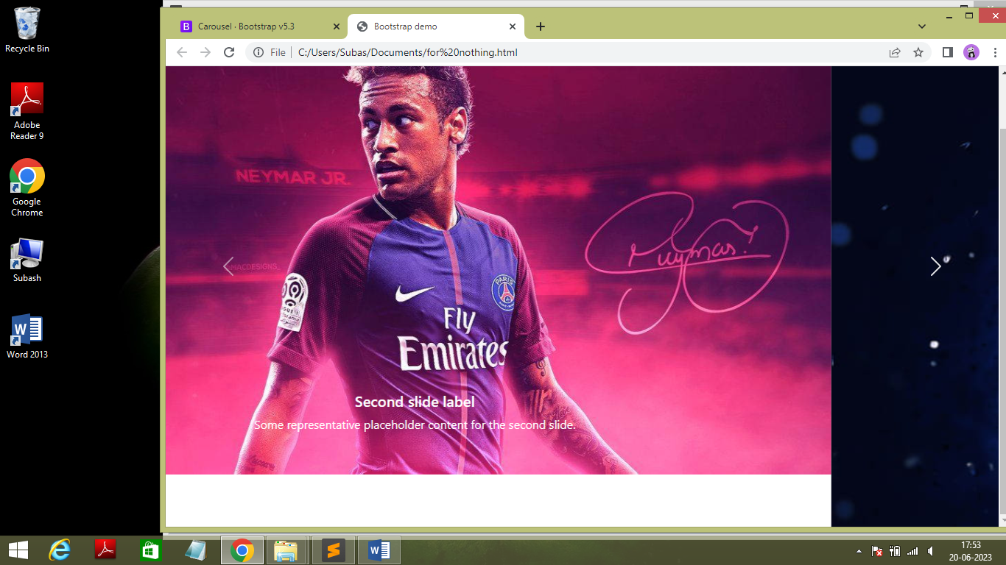

* Code :

<!doctype html>

<html lang="en">

<head>

<meta charset="utf-8">

<meta name="viewport" content="width=device-width, initial-scale=1">

<title>Bootstrap demo</title>

<link href="https://cdn.jsdelivr.net/npm/bootstrap@5.3.0/dist/css/bootstrap.min.css" rel="stylesheet" integrity="sha384-9ndCyUaIbzAi2FUVXJi0CjmCapSmO7SnpJef0486qhLnuZ2cdeRhO02iuK6FUUVM" crossorigin="anonymous">

</head>

<body>

<div id="carouselExample" class="carousel slide carousel-fade" data-bs-ride="carousel">

<div class="carousel-indicators">

<button type="button" data-bs-target="#carouselExampleIndicators" data-bs-slide-to="0" class="active" aria-current="true" aria-label="Slide 1"></button>

<button type="button" data-bs-target="#carouselExampleIndicators" data-bs-slide-to="1" aria-label="Slide 2"></button>

<button type="button" data-bs-target="#carouselExampleIndicators" data-bs-slide-to="2" aria-label="Slide 3"></button>

</div>

<div class="carousel-inner">

<div class="carousel-item active" >

<img src="https://e0.pxfuel.com/wallpapers/483/649/desktop-wallpaper-neymar-jr-soccer-paris-brazilian-psg-parissaintgermain-neymarjr-football-sport-junior.jpg" class="d-block w-100" alt="Neymar...">

<div class="carousel-caption d-none d-md-block" >

<h5>Second slide label</h5>

<p>Some representative placeholder content for the second slide.</p>

</div>

</div>

<div class="carousel-item" >

<img src="https://wallpapers.com/images/hd/neymar-aesthetic-pink-art-3ab6fl15z07ftq9p.jpg" class="d-block w-100" alt="Neymar" >

<div class="carousel-caption d-none d-md-block">

<h5>Second slide label</h5>

<p>Some representative placeholder content for the second slide.</p>

</div>

</div>

<div class="carousel-item">

<img src="https://e0.pxfuel.com/wallpapers/483/649/desktop-wallpaper-neymar-jr-soccer-paris-brazilian-psg-parissaintgermain-neymarjr-football-sport-junior.jpg" class="d-block w-100" alt="Neymar">

<div class="carousel-caption d-none d-md-block">

<h5>Second slide label</h5>

<p>Some representative placeholder content for the second slide.</p>

</div>

</div>

</div>

<button class="carousel-control-prev" type="button" data-bs-target="#carouselExample" data-bs-slide="prev">

<span class="carousel-control-prev-icon" aria-hidden="true"></span>

<span class="visually-hidden">Previous</span>

</button>

<button class="carousel-control-next" type="button" data-bs-target="#carouselExample" data-bs-slide="next">

<span class="carousel-control-next-icon" aria-hidden="true"></span>

<span class="visually-hidden">Next</span>

</button>

</div>

<script src="https://cdn.jsdelivr.net/npm/bootstrap@5.3.0/dist/js/bootstrap.bundle.min.js" integrity="sha384-geWF76RCwLtnZ8qwWowPQNguL3RmwHVBC9FhGdlKrxdiJJigb/j/68SIy3Te4Bkz" crossorigin="anonymous"></script>

</body>

</html>

* + - * + **Form Control**
* **Example**
* Output :

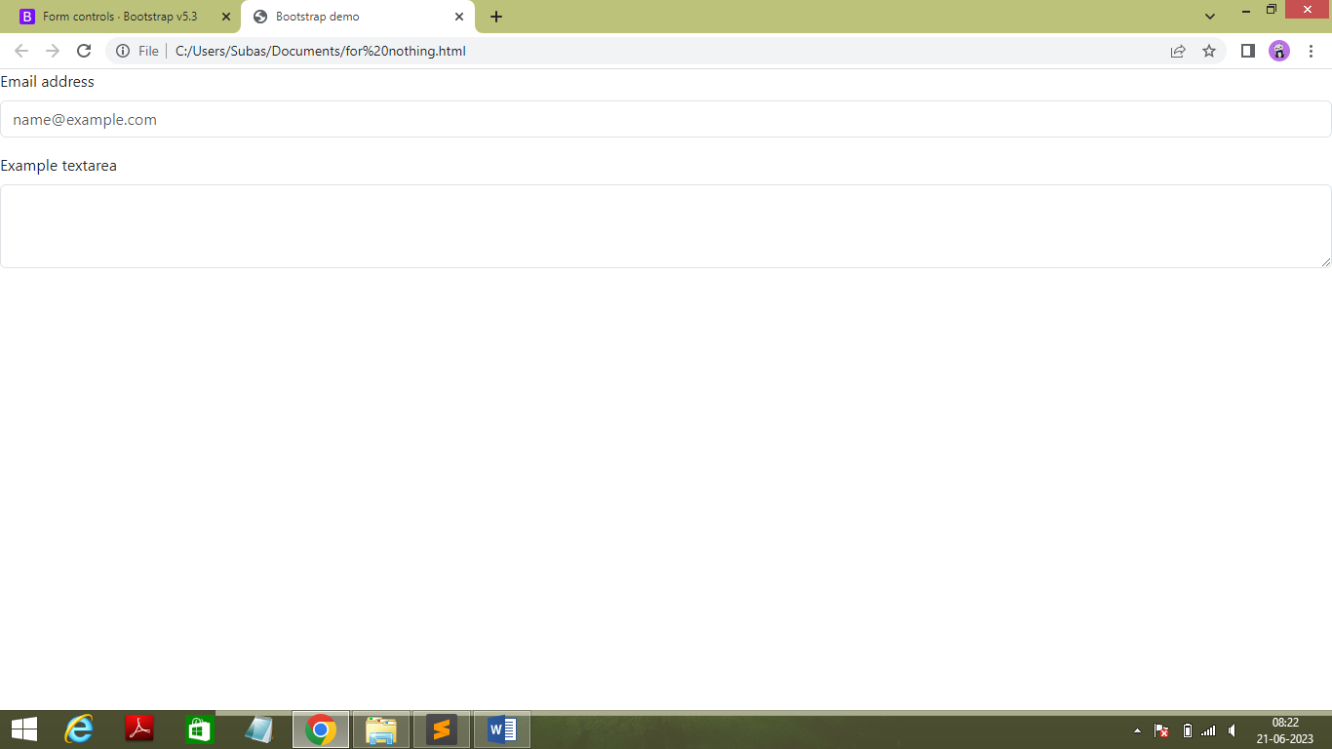

* Code :

<!doctype html>

<html lang="en">

<head>

<meta charset="utf-8">

<meta name="viewport" content="width=device-width, initial-scale=1">

<title>Bootstrap demo</title>

<link href="https://cdn.jsdelivr.net/npm/bootstrap@5.3.0/dist/css/bootstrap.min.css" rel="stylesheet" integrity="sha384-9ndCyUaIbzAi2FUVXJi0CjmCapSmO7SnpJef0486qhLnuZ2cdeRhO02iuK6FUUVM" crossorigin="anonymous">

</head>

<body>

<div class="mb-3">

<label for="exampleFormControlInput1" class="form-label">Email address</label>

<input type="email" class="form-control" id="exampleFormControlInput1" placeholder="name@example.com">

</div>

<div class="mb-3">

<label for="exampleFormControlTextarea1" class="form-label">Example textarea</label>

<textarea class="form-control" id="exampleFormControlTextarea1" rows="3"></textarea>

</div>

<script src="https://cdn.jsdelivr.net/npm/bootstrap@5.3.0/dist/js/bootstrap.bundle.min.js" integrity="sha384-geWF76RCwLtnZ8qwWowPQNguL3RmwHVBC9FhGdlKrxdiJJigb/j/68SIy3Te4Bkz" crossorigin="anonymous"></script>

</body>

</html>

* **Readonly Plain Text**
* Output :

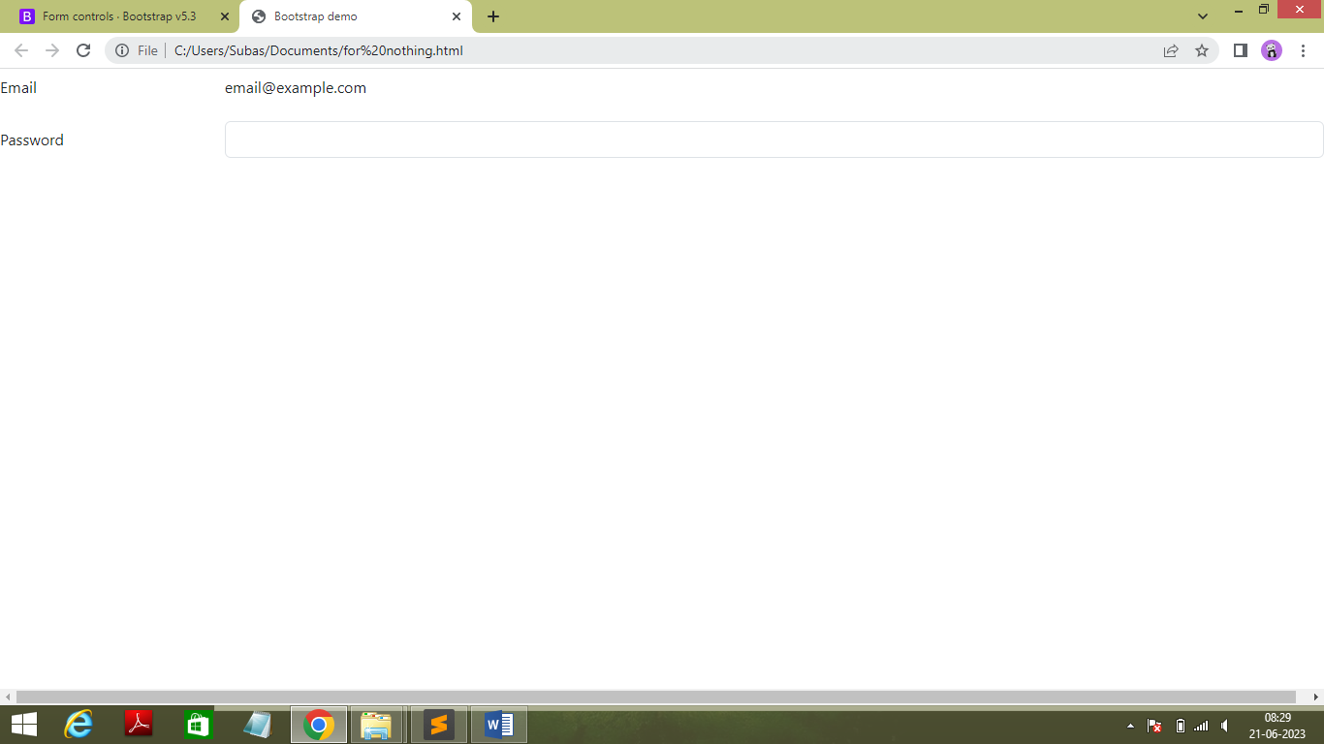

* Code :

<!doctype html>

<html lang="en">

<head>

<meta charset="utf-8">

<meta name="viewport" content="width=device-width, initial-scale=1">

<title>Bootstrap demo</title>

<link href="https://cdn.jsdelivr.net/npm/bootstrap@5.3.0/dist/css/bootstrap.min.css" rel="stylesheet" integrity="sha384-9ndCyUaIbzAi2FUVXJi0CjmCapSmO7SnpJef0486qhLnuZ2cdeRhO02iuK6FUUVM" crossorigin="anonymous">

</head>

<body>

<div class="mb-3 row">

<label for="staticEmail" class="col-sm-2 col-form-label">Email</label>

<div class="col-sm-10">

<input type="text" readonly class="form-control-plaintext" id="staticEmail" value="email@example.com">

</div>

</div>

<div class="mb-3 row">

<label for="inputPassword" class="col-sm-2 col-form-label">Password</label>

<div class="col-sm-10">

<input type="password" class="form-control" id="inputPassword">

</div>

</div>

<script src="https://cdn.jsdelivr.net/npm/bootstrap@5.3.0/dist/js/bootstrap.bundle.min.js" integrity="sha384-geWF76RCwLtnZ8qwWowPQNguL3RmwHVBC9FhGdlKrxdiJJigb/j/68SIy3Te4Bkz" crossorigin="anonymous"></script>

</body>

</html>

* **File Input**
* Output :

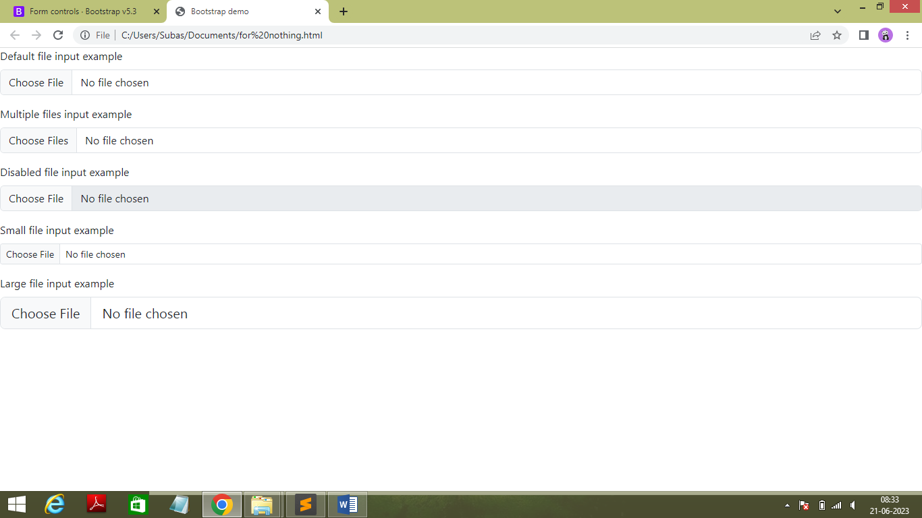

* Code :

<!doctype html>

<html lang="en">

<head>

<meta charset="utf-8">

<meta name="viewport" content="width=device-width, initial-scale=1">

<title>Bootstrap demo</title>

<link href="https://cdn.jsdelivr.net/npm/bootstrap@5.3.0/dist/css/bootstrap.min.css" rel="stylesheet" integrity="sha384-9ndCyUaIbzAi2FUVXJi0CjmCapSmO7SnpJef0486qhLnuZ2cdeRhO02iuK6FUUVM" crossorigin="anonymous">

</head>

<body>

<div class="mb-3">

<label for="formFile" class="form-label">Default file input example</label>

<input class="form-control" type="file" id="formFile">

</div>

<div class="mb-3">

<label for="formFileMultiple" class="form-label">Multiple files input example</label>

<input class="form-control" type="file" id="formFileMultiple" multiple>

</div>

<div class="mb-3">

<label for="formFileDisabled" class="form-label">Disabled file input example</label>

<input class="form-control" type="file" id="formFileDisabled" disabled>

</div>

<div class="mb-3">

<label for="formFileSm" class="form-label">Small file input example</label>

<input class="form-control form-control-sm" id="formFileSm" type="file">

</div>

<div>

<label for="formFileLg" class="form-label">Large file input example</label>

<input class="form-control form-control-lg" id="formFileLg" type="file">

</div>

<script src="https://cdn.jsdelivr.net/npm/bootstrap@5.3.0/dist/js/bootstrap.bundle.min.js" integrity="sha384-geWF76RCwLtnZ8qwWowPQNguL3RmwHVBC9FhGdlKrxdiJJigb/j/68SIy3Te4Bkz" crossorigin="anonymous"></script>

</body>

</html>

* **Color Picker**
* Output : 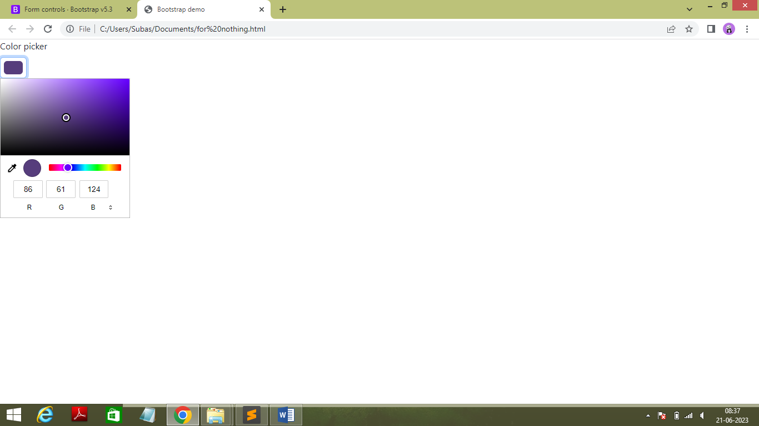
* Code :

<!doctype html>

<html lang="en">

<head>

<meta charset="utf-8">

<meta name="viewport" content="width=device-width, initial-scale=1">

<title>Bootstrap demo</title>

<link href="https://cdn.jsdelivr.net/npm/bootstrap@5.3.0/dist/css/bootstrap.min.css" rel="stylesheet" integrity="sha384-9ndCyUaIbzAi2FUVXJi0CjmCapSmO7SnpJef0486qhLnuZ2cdeRhO02iuK6FUUVM" crossorigin="anonymous">

</head>

<body>

<label for="exampleColorInput" class="form-label">Color picker</label>

<input type="color" class="form-control form-control-color" id="exampleColorInput" value="#563d7c" title="Choose your color">

<script src="https://cdn.jsdelivr.net/npm/bootstrap@5.3.0/dist/js/bootstrap.bundle.min.js" integrity="sha384-geWF76RCwLtnZ8qwWowPQNguL3RmwHVBC9FhGdlKrxdiJJigb/j/68SIy3Te4Bkz" crossorigin="anonymous"></script>

</body>

</html>

* + - * + **Select**
* **Default Select**
* Output :

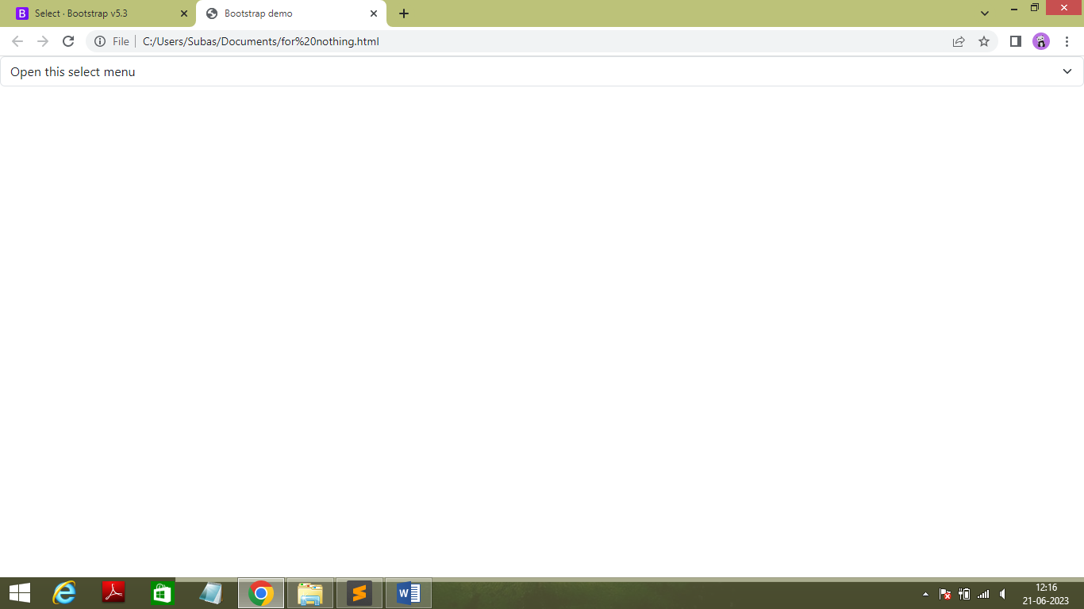

* Code :

<!doctype html>

<html lang="en">

<head>

<meta charset="utf-8">

<meta name="viewport" content="width=device-width, initial-scale=1">

<title>Bootstrap demo</title>

<link href="https://cdn.jsdelivr.net/npm/bootstrap@5.3.0/dist/css/bootstrap.min.css" rel="stylesheet" integrity="sha384-9ndCyUaIbzAi2FUVXJi0CjmCapSmO7SnpJef0486qhLnuZ2cdeRhO02iuK6FUUVM" crossorigin="anonymous">

</head>

<select class="form-select" aria-label="Default select example">

<option selected>Open this select menu</option>

<option value="1">One</option>

<option value="2">Two</option>

<option value="3">Three</option>

</select>

<script src="https://cdn.jsdelivr.net/npm/bootstrap@5.3.0/dist/js/bootstrap.bundle.min.js" integrity="sha384-geWF76RCwLtnZ8qwWowPQNguL3RmwHVBC9FhGdlKrxdiJJigb/j/68SIy3Te4Bkz" crossorigin="anonymous"></script>

</body>

</html>

* + - * + **Sizing**
* Output :

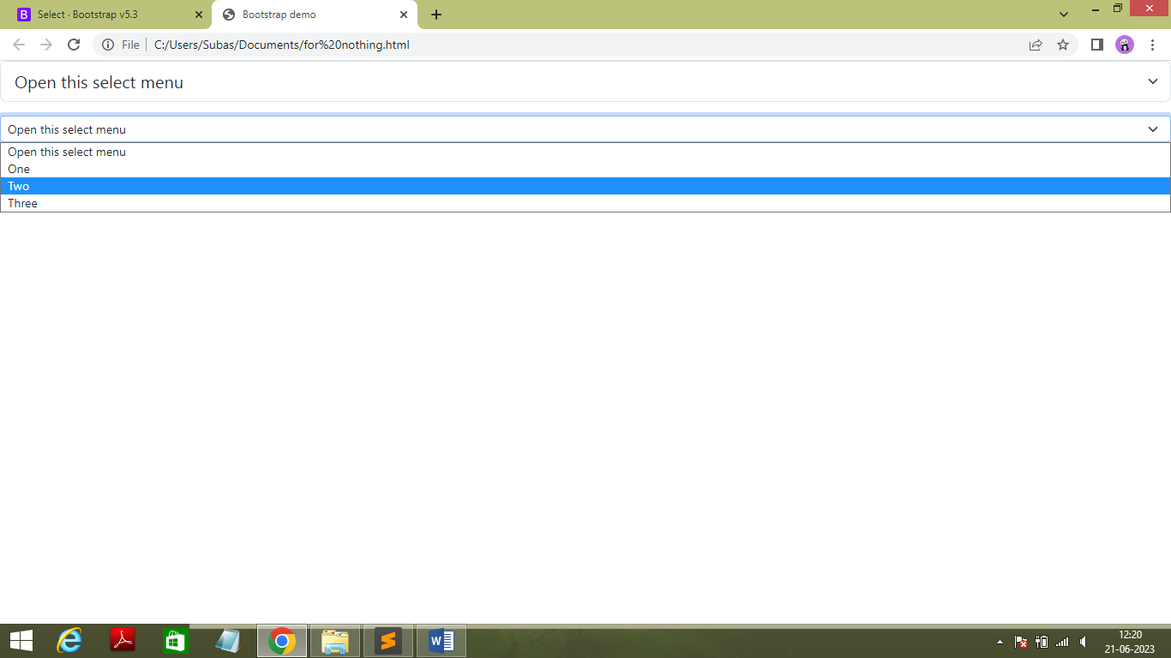

* Code :

<!doctype html>

<html lang="en">

<head>

<meta charset="utf-8">

<meta name="viewport" content="width=device-width, initial-scale=1">

<title>Bootstrap demo</title>

<link href="https://cdn.jsdelivr.net/npm/bootstrap@5.3.0/dist/css/bootstrap.min.css" rel="stylesheet" integrity="sha384-9ndCyUaIbzAi2FUVXJi0CjmCapSmO7SnpJef0486qhLnuZ2cdeRhO02iuK6FUUVM" crossorigin="anonymous">

</head>

<body>

<select class="form-select form-select-lg mb-3" aria-label=".form-select-lg example">

<option selected>Open this select menu</option>

<option value="1">One</option>

<option value="2">Two</option>

<option value="3">Three</option>

</select>

<select class="form-select form-select-sm" aria-label=".form-select-sm example">

<option selected>Open this select menu</option>

<option value="1">One</option>

<option value="2">Two</option>

<option value="3">Three</option>

</select>

<script src="https://cdn.jsdelivr.net/npm/bootstrap@5.3.0/dist/js/bootstrap.bundle.min.js" integrity="sha384-geWF76RCwLtnZ8qwWowPQNguL3RmwHVBC9FhGdlKrxdiJJigb/j/68SIy3Te4Bkz" crossorigin="anonymous"></script>

</body>

</html>

**Disabled**

* Output :

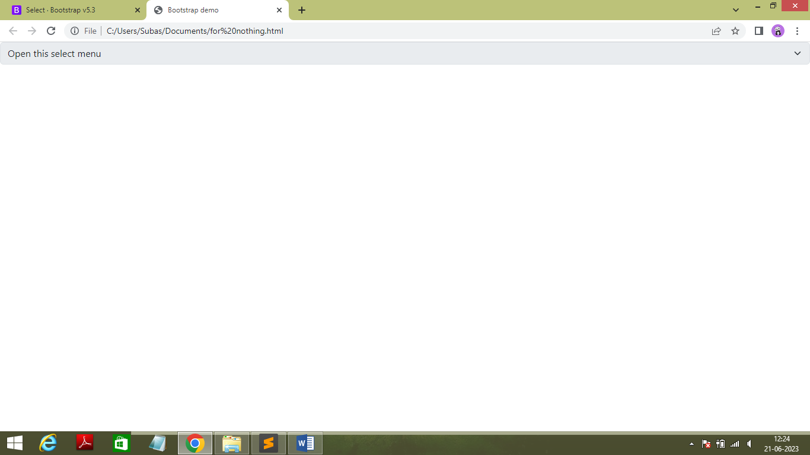

* Code :

<!doctype html>

<html lang="en">

<head>

<meta charset="utf-8">

<meta name="viewport" content="width=device-width, initial-scale=1">

<title>Bootstrap demo</title>

<link href="https://cdn.jsdelivr.net/npm/bootstrap@5.3.0/dist/css/bootstrap.min.css" rel="stylesheet" integrity="sha384-9ndCyUaIbzAi2FUVXJi0CjmCapSmO7SnpJef0486qhLnuZ2cdeRhO02iuK6FUUVM" crossorigin="anonymous">

</head>

<body>

<select class="form-select" aria-label="Disabled select example" disabled>

<option selected>Open this select menu</option>

<option value="1">One</option>

<option value="2">Two</option>

<option value="3">Three</option>

</select>

<script src="https://cdn.jsdelivr.net/npm/bootstrap@5.3.0/dist/js/bootstrap.bundle.min.js" integrity="sha384-geWF76RCwLtnZ8qwWowPQNguL3RmwHVBC9FhGdlKrxdiJJigb/j/68SIy3Te4Bkz" crossorigin="anonymous"></script>

</body>

</html>

* + - * **Checkbox and Radio**

* + - * + **Chckbox**
* Output :

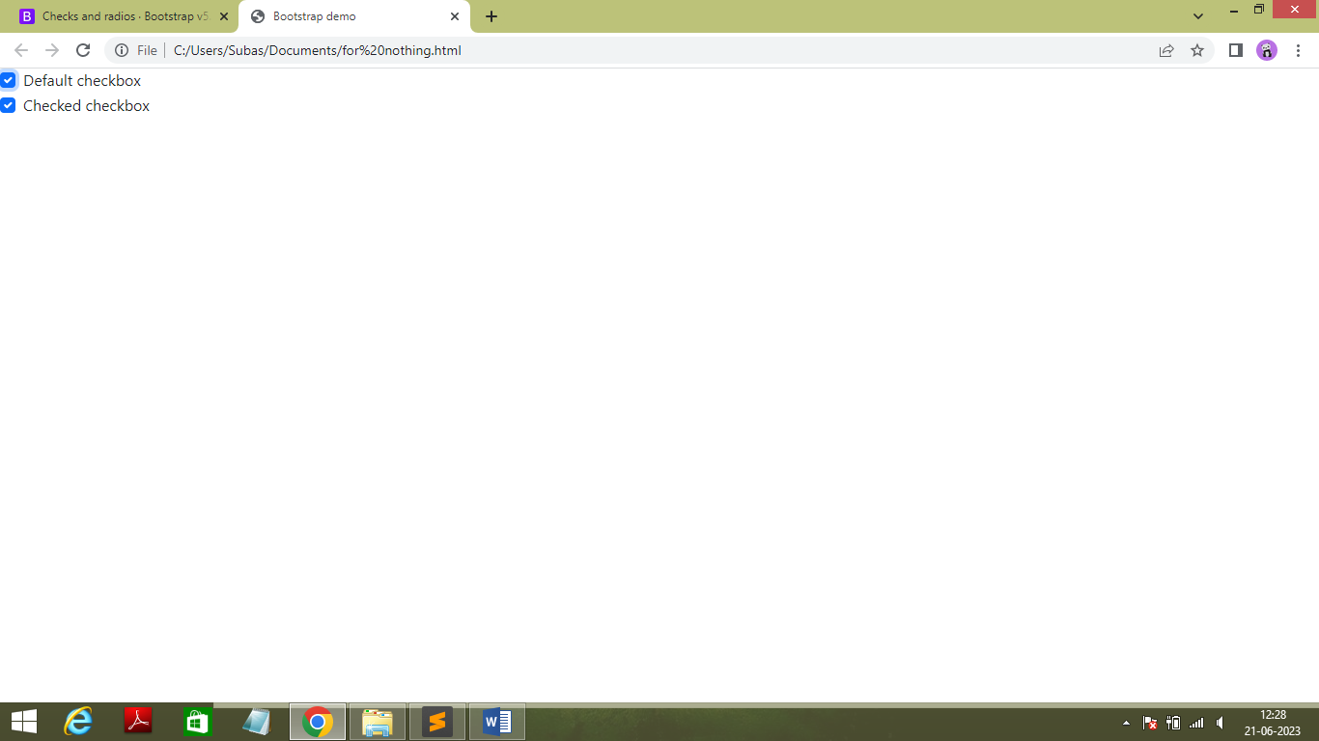

* Code :

<!doctype html>

<html lang="en">

<head>

<meta charset="utf-8">

<meta name="viewport" content="width=device-width, initial-scale=1">

<title>Bootstrap demo</title>

<link href="https://cdn.jsdelivr.net/npm/bootstrap@5.3.0/dist/css/bootstrap.min.css" rel="stylesheet" integrity="sha384-9ndCyUaIbzAi2FUVXJi0CjmCapSmO7SnpJef0486qhLnuZ2cdeRhO02iuK6FUUVM" crossorigin="anonymous">

</head>

<body>

<div class="form-check">

<input class="form-check-input" type="checkbox" value="" id="flexCheckDefault">

<label class="form-check-label" for="flexCheckDefault">

Default checkbox

</label>

</div>

<div class="form-check">

<input class="form-check-input" type="checkbox" value="" id="flexCheckChecked" checked>

<label class="form-check-label" for="flexCheckChecked">

Checked checkbox

</label>

</div>

<script src="https://cdn.jsdelivr.net/npm/bootstrap@5.3.0/dist/js/bootstrap.bundle.min.js" integrity="sha384-geWF76RCwLtnZ8qwWowPQNguL3RmwHVBC9FhGdlKrxdiJJigb/j/68SIy3Te4Bkz" crossorigin="anonymous"></script>

</body>

</html>

* **Radio**
* Output :

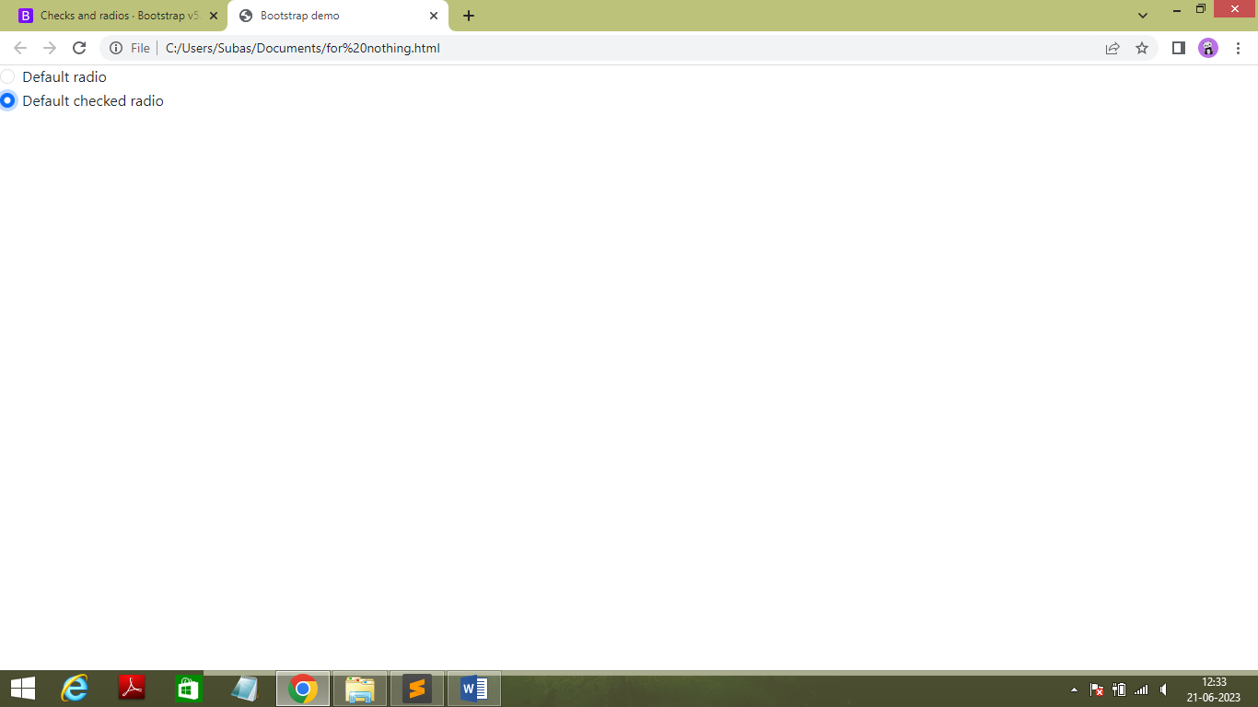

* Code :

<!doctype html>

<html lang="en">

<head>

<meta charset="utf-8">

<meta name="viewport" content="width=device-width, initial-scale=1">

<title>Bootstrap demo</title>

<link href="https://cdn.jsdelivr.net/npm/bootstrap@5.3.0/dist/css/bootstrap.min.css" rel="stylesheet" integrity="sha384-9ndCyUaIbzAi2FUVXJi0CjmCapSmO7SnpJef0486qhLnuZ2cdeRhO02iuK6FUUVM" crossorigin="anonymous">

</head>

<body>

<div class="form-check">

<input class="form-check-input" type="radio" name="flexRadioDefault" id="flexRadioDefault1">

<label class="form-check-label" for="flexRadioDefault1">

Default radio

</label>

</div>

<div class="form-check">

<input class="form-check-input" type="radio" name="flexRadioDefault" id="flexRadioDefault2" checked>

<label class="form-check-label" for="flexRadioDefault2">

Default checked radio

</label>

</div>

<script src="https://cdn.jsdelivr.net/npm/bootstrap@5.3.0/dist/js/bootstrap.bundle.min.js" integrity="sha384-geWF76RCwLtnZ8qwWowPQNguL3RmwHVBC9FhGdlKrxdiJJigb/j/68SIy3Te4Bkz" crossorigin="anonymous"></script>

</body>

</html>

* **Switches**
* Output :

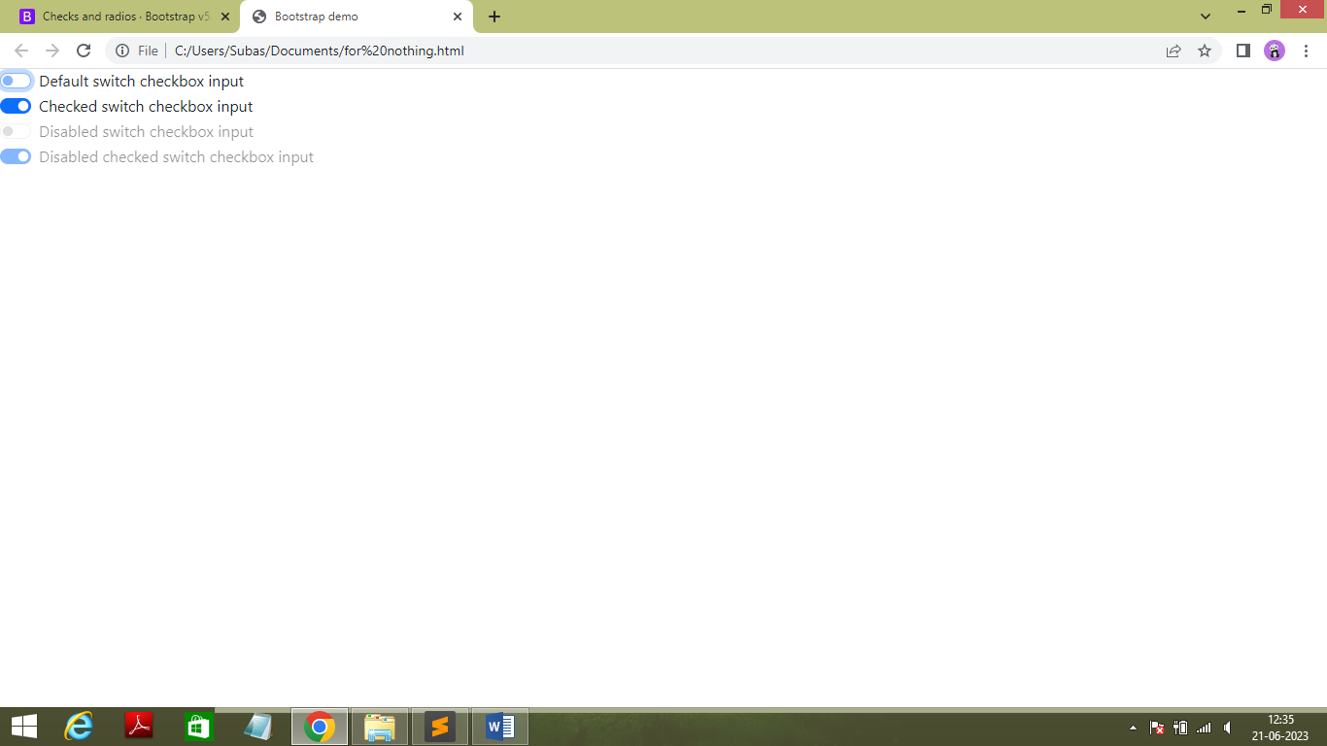

* Code :

<!doctype html>

<html lang="en">

<head>

<meta charset="utf-8">

<meta name="viewport" content="width=device-width, initial-scale=1">

<title>Bootstrap demo</title>

<link href="https://cdn.jsdelivr.net/npm/bootstrap@5.3.0/dist/css/bootstrap.min.css" rel="stylesheet" integrity="sha384-9ndCyUaIbzAi2FUVXJi0CjmCapSmO7SnpJef0486qhLnuZ2cdeRhO02iuK6FUUVM" crossorigin="anonymous">

</head>

<body>

<div class="form-check form-switch">

<input class="form-check-input" type="checkbox" role="switch" id="flexSwitchCheckDefault">

<label class="form-check-label" for="flexSwitchCheckDefault">Default switch checkbox input</label>

</div>

<div class="form-check form-switch">

<input class="form-check-input" type="checkbox" role="switch" id="flexSwitchCheckChecked" checked>

<label class="form-check-label" for="flexSwitchCheckChecked">Checked switch checkbox input</label>

</div>

<div class="form-check form-switch">

<input class="form-check-input" type="checkbox" role="switch" id="flexSwitchCheckDisabled" disabled>

<label class="form-check-label" for="flexSwitchCheckDisabled">Disabled switch checkbox input</label>

</div>

<div class="form-check form-switch">

<input class="form-check-input" type="checkbox" role="switch" id="flexSwitchCheckCheckedDisabled" checked disabled>

<label class="form-check-label" for="flexSwitchCheckCheckedDisabled">Disabled checked switch checkbox input</label>

</div>

<script src="https://cdn.jsdelivr.net/npm/bootstrap@5.3.0/dist/js/bootstrap.bundle.min.js" integrity="sha384-geWF76RCwLtnZ8qwWowPQNguL3RmwHVBC9FhGdlKrxdiJJigb/j/68SIy3Te4Bkz" crossorigin="anonymous"></script>

</body>

</html>

* + - **Reverse Checkbox ,Radio and Switches**
* Output :

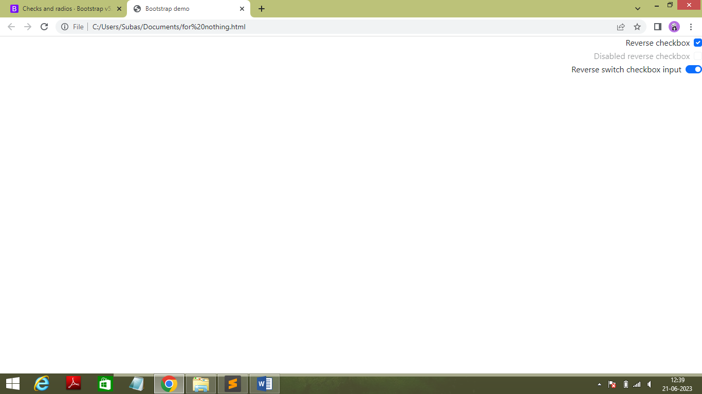

* Code :

<!doctype html>

<html lang="en">

<head>

<meta charset="utf-8">

<meta name="viewport" content="width=device-width, initial-scale=1">

<title>Bootstrap demo</title>

<link href="https://cdn.jsdelivr.net/npm/bootstrap@5.3.0/dist/css/bootstrap.min.css" rel="stylesheet" integrity="sha384-9ndCyUaIbzAi2FUVXJi0CjmCapSmO7SnpJef0486qhLnuZ2cdeRhO02iuK6FUUVM" crossorigin="anonymous">

</head>

<body>

<div class="form-check form-check-reverse">

<input class="form-check-input" type="checkbox" value="" id="reverseCheck1">

<label class="form-check-label" for="reverseCheck1">

Reverse checkbox

</label>

</div>

<div class="form-check form-check-reverse">

<input class="form-check-input" type="checkbox" value="" id="reverseCheck2" disabled>

<label class="form-check-label" for="reverseCheck2">

Disabled reverse checkbox

</label>

</div>

<div class="form-check form-switch form-check-reverse">

<input class="form-check-input" type="checkbox" id="flexSwitchCheckReverse">

<label class="form-check-label" for="flexSwitchCheckReverse">Reverse switch checkbox input</label>

</div>

<script src="https://cdn.jsdelivr.net/npm/bootstrap@5.3.0/dist/js/bootstrap.bundle.min.js" integrity="sha384-geWF76RCwLtnZ8qwWowPQNguL3RmwHVBC9FhGdlKrxdiJJigb/j/68SIy3Te4Bkz" crossorigin="anonymous"></script>

</body>

</html>

* **Table**
* **Overview**
* Output :

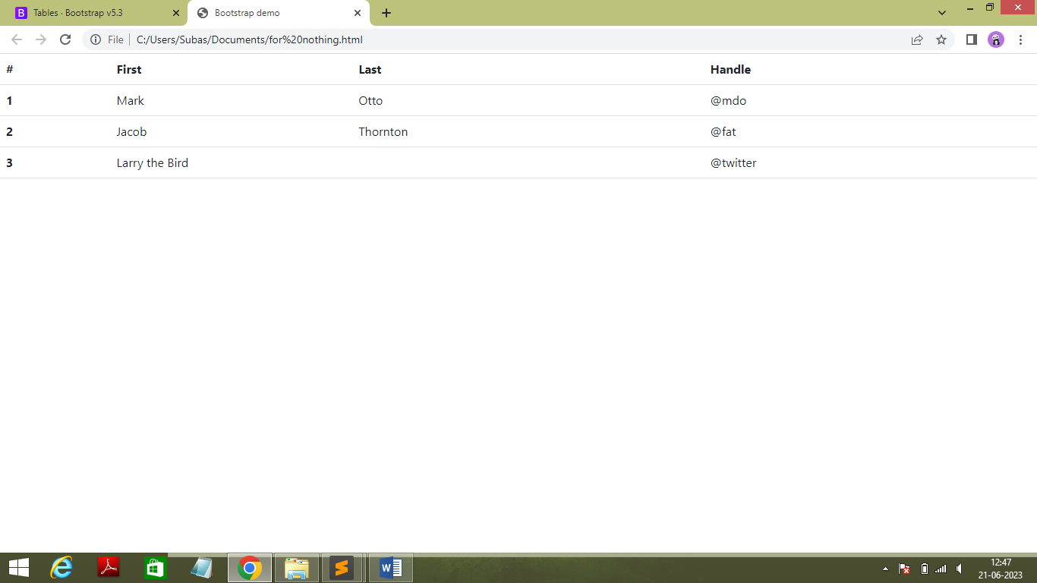

* Code :

<!doctype html>

<html lang="en">

<head>

<meta charset="utf-8">

<meta name="viewport" content="width=device-width, initial-scale=1">

<title>Bootstrap demo</title>

<link href="https://cdn.jsdelivr.net/npm/bootstrap@5.3.0/dist/css/bootstrap.min.css" rel="stylesheet" integrity="sha384-9ndCyUaIbzAi2FUVXJi0CjmCapSmO7SnpJef0486qhLnuZ2cdeRhO02iuK6FUUVM" crossorigin="anonymous">

</head>

<table class="table">

<thead>

<tr>

<th scope="col">#</th>

<th scope="col">First</th>

<th scope="col">Last</th>

<th scope="col">Handle</th>

</tr>

</thead>

<tbody>

<tr>

<th scope="row">1</th>

<td>Mark</td>

<td>Otto</td>

<td>@mdo</td>

</tr>

<tr>

<th scope="row">2</th>

<td>Jacob</td>

<td>Thornton</td>

<td>@fat</td>

</tr>

<tr>

<th scope="row">3</th>

<td colspan="2">Larry the Bird</td>

<td>@twitter</td>

</tr>

</tbody>

</table>

<script src="https://cdn.jsdelivr.net/npm/bootstrap@5.3.0/dist/js/bootstrap.bundle.min.js" integrity="sha384-geWF76RCwLtnZ8qwWowPQNguL3RmwHVBC9FhGdlKrxdiJJigb/j/68SIy3Te4Bkz" crossorigin="anonymous"></script>

</body>

</html>

* **Striped Table with Variants**
* Output :

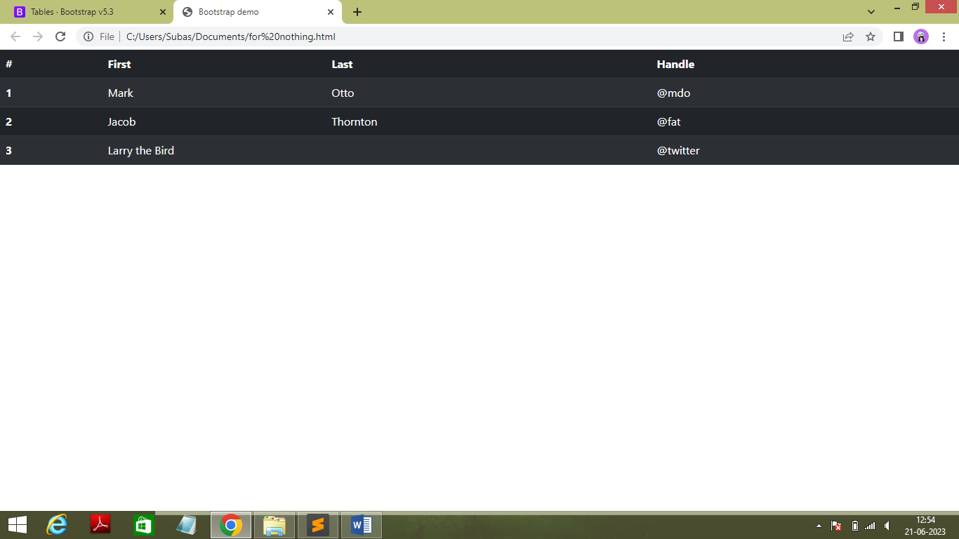

* Code :

<!doctype html>

<html lang="en">

<head>

<meta charset="utf-8">

<meta name="viewport" content="width=device-width, initial-scale=1">

<title>Bootstrap demo</title>

<link href="https://cdn.jsdelivr.net/npm/bootstrap@5.3.0/dist/css/bootstrap.min.css" rel="stylesheet" integrity="sha384-9ndCyUaIbzAi2FUVXJi0CjmCapSmO7SnpJef0486qhLnuZ2cdeRhO02iuK6FUUVM" crossorigin="anonymous">

</head>

<table class="table table-dark table-striped ">

<thead>

<tr>

<th scope="col">#</th>

<th scope="col">First</th>

<th scope="col">Last</th>

<th scope="col">Handle</th>

</tr>

</thead>

<tbody>

<tr>

<th scope="row">1</th>

<td>Mark</td>

<td>Otto</td>

<td>@mdo</td>

</tr>

<tr>

<th scope="row">2</th>

<td>Jacob</td>

<td>Thornton</td>

<td>@fat</td>

</tr>

<tr>

<th scope="row">3</th>

<td colspan="2">Larry the Bird</td>

<td>@twitter</td>

</tr>

</tbody>

</table>

<script src="https://cdn.jsdelivr.net/npm/bootstrap@5.3.0/dist/js/bootstrap.bundle.min.js" integrity="sha384-geWF76RCwLtnZ8qwWowPQNguL3RmwHVBC9FhGdlKrxdiJJigb/j/68SIy3Te4Bkz" crossorigin="anonymous"></script>

</body>

</html>

* + - * **Table Bordered**
* Output :

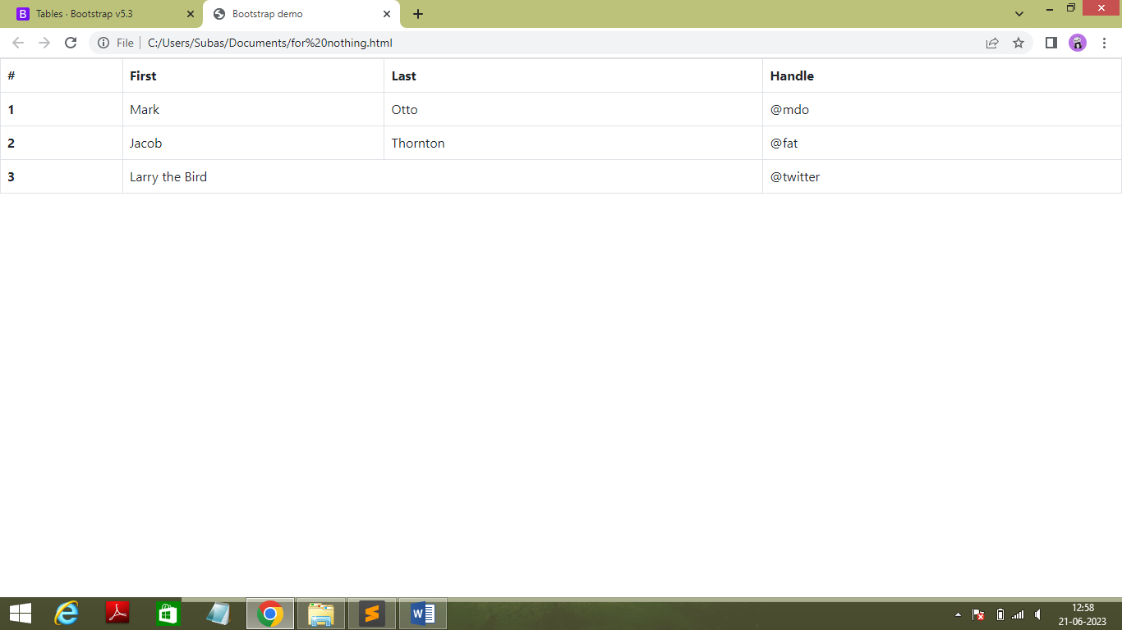

* Code :

<!doctype html>

<html lang="en">

<head>

<meta charset="utf-8">

<meta name="viewport" content="width=device-width, initial-scale=1">

<title>Bootstrap demo</title>

<link href="https://cdn.jsdelivr.net/npm/bootstrap@5.3.0/dist/css/bootstrap.min.css" rel="stylesheet" integrity="sha384-9ndCyUaIbzAi2FUVXJi0CjmCapSmO7SnpJef0486qhLnuZ2cdeRhO02iuK6FUUVM" crossorigin="anonymous">

</head>

<table class="table table-bordered ">

<thead>

<tr>

<th scope="col">#</th>

<th scope="col">First</th>

<th scope="col">Last</th>

<th scope="col">Handle</th>

</tr>

</thead>

<tbody>

<tr>

<th scope="row">1</th>

<td>Mark</td>

<td>Otto</td>

<td>@mdo</td>

</tr>

<tr>

<th scope="row">2</th>

<td>Jacob</td>

<td>Thornton</td>

<td>@fat</td>

</tr>

<tr>

<th scope="row">3</th>

<td colspan="2">Larry the Bird</td>

<td>@twitter</td>

</tr>

</tbody>

</table>

<script src="https://cdn.jsdelivr.net/npm/bootstrap@5.3.0/dist/js/bootstrap.bundle.min.js" integrity="sha384-geWF76RCwLtnZ8qwWowPQNguL3RmwHVBC9FhGdlKrxdiJJigb/j/68SIy3Te4Bkz" crossorigin="anonymous"></script>

</body>

</html>

* + - * **Table Group Divider**
* Output :

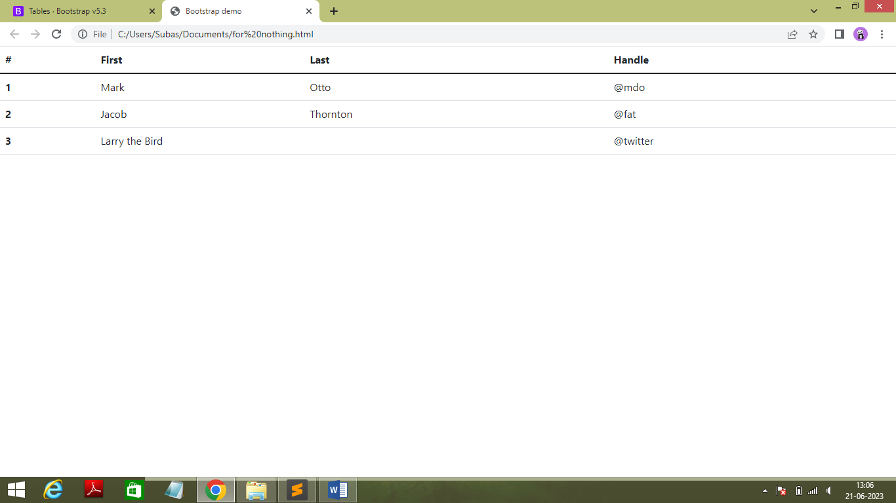

* Code :

<!doctype html>

<html lang="en">

<head>

<meta charset="utf-8">

<meta name="viewport" content="width=device-width, initial-scale=1">

<title>Bootstrap demo</title>

<link href="https://cdn.jsdelivr.net/npm/bootstrap@5.3.0/dist/css/bootstrap.min.css" rel="stylesheet" integrity="sha384-9ndCyUaIbzAi2FUVXJi0CjmCapSmO7SnpJef0486qhLnuZ2cdeRhO02iuK6FUUVM" crossorigin="anonymous">

</head>

<table class="table">

<thead>

<tr>

<th scope="col">#</th>

<th scope="col">First</th>

<th scope="col">Last</th>

<th scope="col">Handle</th>

</tr>

</thead>

<tbody class="table-group-divider">

<tr>

<th scope="row">1</th>

<td>Mark</td>

<td>Otto</td>

<td>@mdo</td>

</tr>

<tr>

<th scope="row">2</th>

<td>Jacob</td>

<td>Thornton</td>

<td>@fat</td>

</tr>

<tr>

<th scope="row">3</th>

<td colspan="2">Larry the Bird</td>

<td>@twitter</td>

</tr>

</tbody>

</table>

<script src="https://cdn.jsdelivr.net/npm/bootstrap@5.3.0/dist/js/bootstrap.bundle.min.js" integrity="sha384-geWF76RCwLtnZ8qwWowPQNguL3RmwHVBC9FhGdlKrxdiJJigb/j/68SIy3Te4Bkz" crossorigin="anonymous"></script>

</body>

</html>

* + - * **Toasts**
* **Overview of Toast**
* Output :

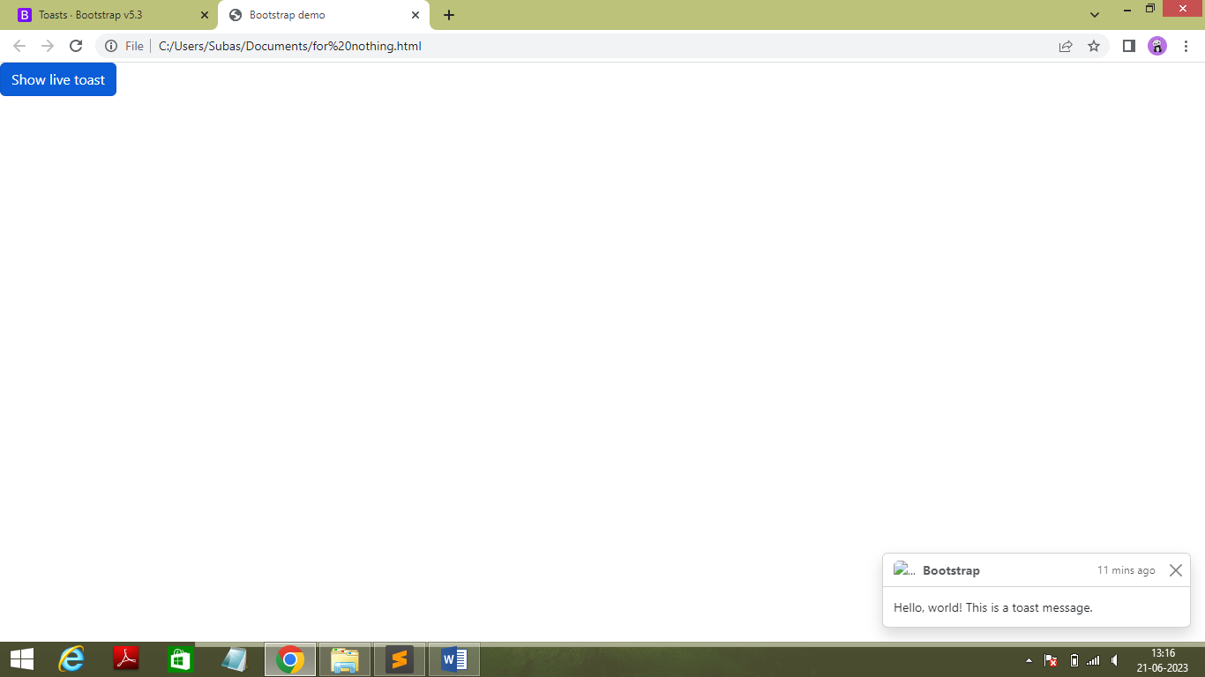

* Code :

<!doctype html>

<html lang="en">

<head>

<meta charset="utf-8">

<meta name="viewport" content="width=device-width, initial-scale=1">

<title>Bootstrap demo</title>

<link href="https://cdn.jsdelivr.net/npm/bootstrap@5.3.0/dist/css/bootstrap.min.css" rel="stylesheet" integrity="sha384-9ndCyUaIbzAi2FUVXJi0CjmCapSmO7SnpJef0486qhLnuZ2cdeRhO02iuK6FUUVM" crossorigin="anonymous">

</head>

<body>

<button type="button" class="btn btn-primary" id="liveToastBtn">Show live toast</button>

<div class="toast-container position-fixed bottom-0 end-0 p-3">

<div id="liveToast" class="toast" role="alert" aria-live="assertive" aria-atomic="true">

<div class="toast-header">

<img src="..." class="rounded me-2" alt="...">

<strong class="me-auto">Bootstrap</strong>

<small>11 mins ago</small>

<button type="button" class="btn-close" data-bs-dismiss="toast" aria-label="Close"></button>

</div>

<div class="toast-body">

Hello, world! This is a toast message.

</div>

</div>

</div>

<script src="https://cdn.jsdelivr.net/npm/bootstrap@5.3.0/dist/js/bootstrap.bundle.min.js" integrity="sha384-geWF76RCwLtnZ8qwWowPQNguL3RmwHVBC9FhGdlKrxdiJJigb/j/68SIy3Te4Bkz" crossorigin="anonymous"></script>

<script >

const toastTrigger = document.getElementById('liveToastBtn')

const toastLiveExample = document.getElementById('liveToast')

if (toastTrigger) {

const toastBootstrap = bootstrap.Toast.getOrCreateInstance(toastLiveExample)

toastTrigger.addEventListener('click', () => {

toastBootstrap.show()

})

}

</script>

</body>

</html>

* **Color Schemes**
* Output :

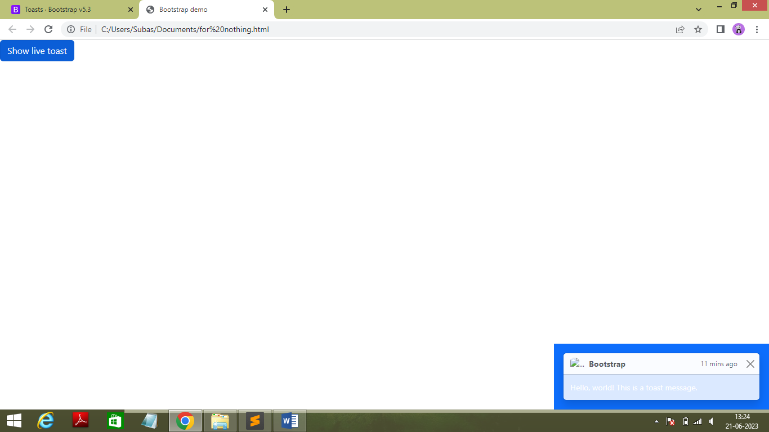

* Code :

<!doctype html>

<html lang="en">

<head>

<meta charset="utf-8">

<meta name="viewport" content="width=device-width, initial-scale=1">

<title>Bootstrap demo</title>

<link href="https://cdn.jsdelivr.net/npm/bootstrap@5.3.0/dist/css/bootstrap.min.css" rel="stylesheet" integrity="sha384-9ndCyUaIbzAi2FUVXJi0CjmCapSmO7SnpJef0486qhLnuZ2cdeRhO02iuK6FUUVM" crossorigin="anonymous">

</head>

<body>

<button type="button" class="btn btn-primary" id="liveToastBtn">Show live toast</button>

<div class="toast-container position-fixed text-bg-primary bottom-0 end-0 p-3">

<div id="liveToast" class="toast" role="alert" aria-live="assertive" aria-atomic="true">

<div class="toast-header">

<img src="..." class="rounded me-2" alt="...">

<strong class="me-auto">Bootstrap</strong>

<small>11 mins ago</small>

<button type="button" class="btn-close" data-bs-dismiss="toast" aria-label="Close"></button>

</div>

<div class="toast-body">

Hello, world! This is a toast message.

</div>

</div>

</div>

<script src="https://cdn.jsdelivr.net/npm/bootstrap@5.3.0/dist/js/bootstrap.bundle.min.js" integrity="sha384-geWF76RCwLtnZ8qwWowPQNguL3RmwHVBC9FhGdlKrxdiJJigb/j/68SIy3Te4Bkz" crossorigin="anonymous"></script>

<script >

const toastTrigger = document.getElementById('liveToastBtn')

const toastLiveExample = document.getElementById('liveToast')

if (toastTrigger) {

const toastBootstrap = bootstrap.Toast.getOrCreateInstance(toastLiveExample)

toastTrigger.addEventListener('click', () => {

toastBootstrap.show()

})

}

</script>

</body>

</html>

* + - * **Modal**
    - **Modal components with example**
* Output :

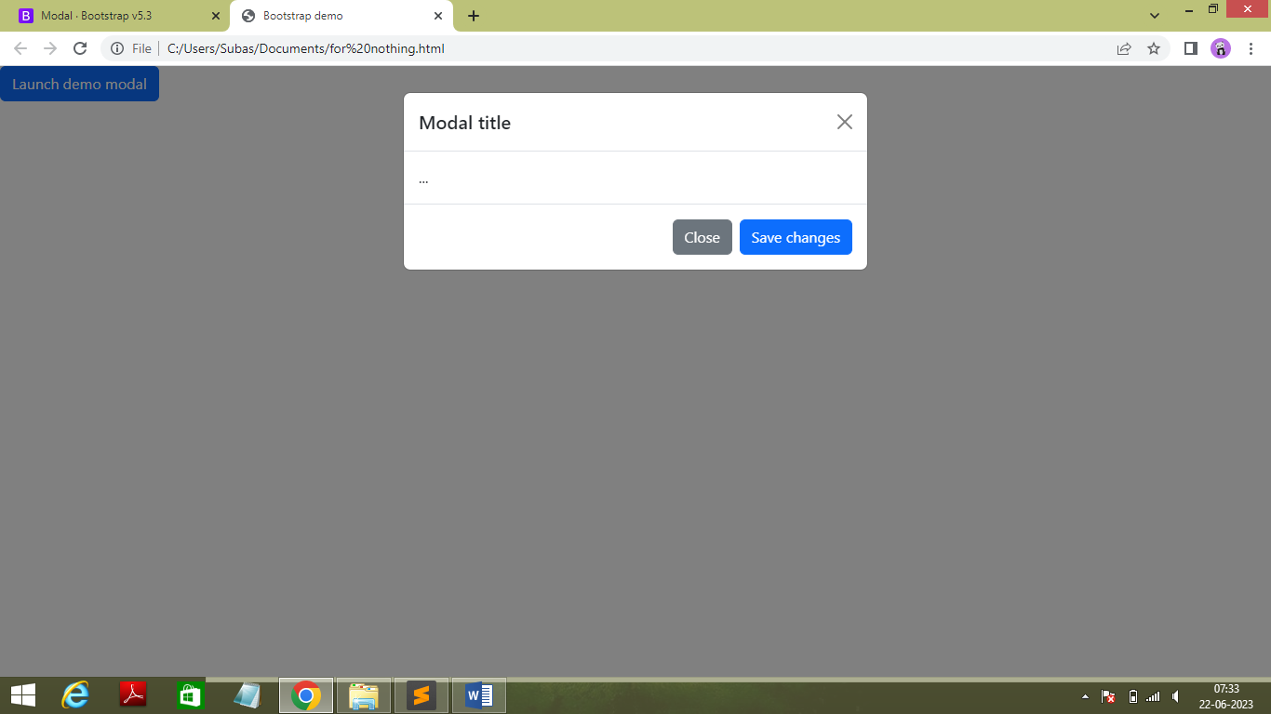

* Code **:**

<!doctype html>

<html lang="en">

<head>

<meta charset="utf-8">

<meta name="viewport" content="width=device-width, initial-scale=1">

<title>Bootstrap demo</title>

<link href="https://cdn.jsdelivr.net/npm/bootstrap@5.3.0/dist/css/bootstrap.min.css" rel="stylesheet" integrity="sha384-9ndCyUaIbzAi2FUVXJi0CjmCapSmO7SnpJef0486qhLnuZ2cdeRhO02iuK6FUUVM" crossorigin="anonymous">

</head>

<body>

<!-- Button trigger modal -->

<button type="button" class="btn btn-primary" data-bs-toggle="modal" data-bs-target="#exampleModal">

Launch demo modal

</button>

<!-- Modal -->

<div class="modal fade" id="exampleModal" tabindex="-1" aria-labelledby="exampleModalLabel" aria-hidden="true">

<div class="modal-dialog">

<div class="modal-content">

<div class="modal-header">

<h1 class="modal-title fs-5" id="exampleModalLabel">Modal title</h1>

<button type="button" class="btn-close" data-bs-dismiss="modal" aria-label="Close"></button>

</div>

<div class="modal-body">

...

</div>

<div class="modal-footer">

<button type="button" class="btn btn-secondary" data-bs-dismiss="modal">Close</button>

<button type="button" class="btn btn-primary">Save changes</button>

</div>

</div>

</div>

</div>

<script src="https://cdn.jsdelivr.net/npm/bootstrap@5.3.0/dist/js/bootstrap.bundle.min.js" integrity="sha384-geWF76RCwLtnZ8qwWowPQNguL3RmwHVBC9FhGdlKrxdiJJigb/j/68SIy3Te4Bkz" crossorigin="anonymous"></script>

<script >

const toastTrigger = document.getElementById('liveToastBtn')

const toastLiveExample = document.getElementById('liveToast')

if (toastTrigger) {

const toastBootstrap = bootstrap.Toast.getOrCreateInstance(toastLiveExample)

toastTrigger.addEventListener('click', () => {

toastBootstrap.show()

})

}

</script>

</body>

</html>

* + - * **Static backdrop**
* Output :

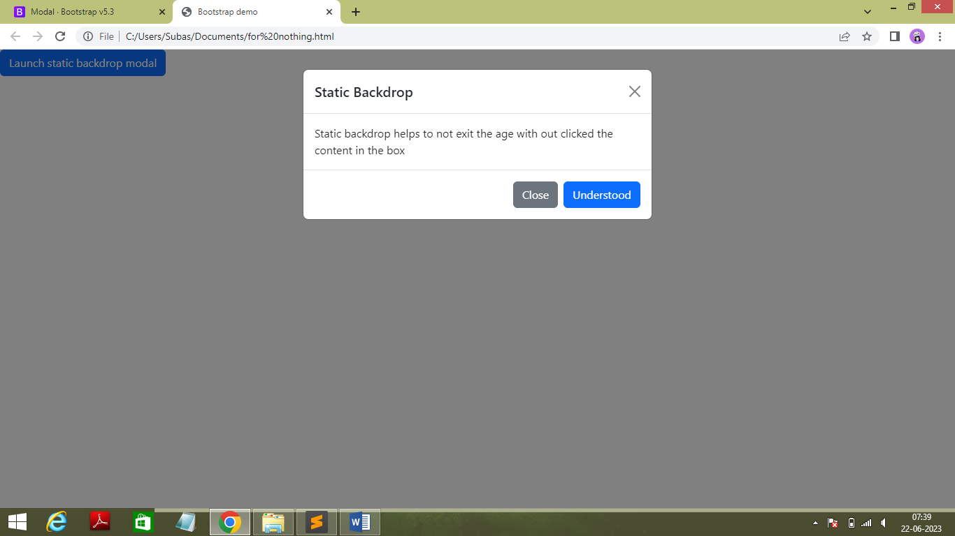

* Code :

<!doctype html>

<html lang="en">

<head>

<meta charset="utf-8">

<meta name="viewport" content="width=device-width, initial-scale=1">

<title>Bootstrap demo</title>

<link href="https://cdn.jsdelivr.net/npm/bootstrap@5.3.0/dist/css/bootstrap.min.css" rel="stylesheet" integrity="sha384-9ndCyUaIbzAi2FUVXJi0CjmCapSmO7SnpJef0486qhLnuZ2cdeRhO02iuK6FUUVM" crossorigin="anonymous">

</head>

<body>

<!-- Button trigger modal -->

<button type="button" class="btn btn-primary" data-bs-toggle="modal" data-bs-target="#staticBackdrop">

Launch static backdrop modal

</button>

<!-- Modal -->

<div class="modal fade" id="staticBackdrop" data-bs-backdrop="static" data-bs-keyboard="false" tabindex="-1" aria-labelledby="staticBackdropLabel" aria-hidden="true">

<div class="modal-dialog">

<div class="modal-content">

<div class="modal-header">

<h1 class="modal-title fs-5" id="staticBackdropLabel">Static Backdrop</h1>

<button type="button" class="btn-close" data-bs-dismiss="modal" aria-label="Close"></button>

</div>

<div class="modal-body">

Static backdrop helps to not exit the age with out clicked the content in the box

</div>

<div class="modal-footer">

<button type="button" class="btn btn-secondary" data-bs-dismiss="modal">Close</button>

<button type="button" class="btn btn-primary">Understood</button>

</div>

</div>

</div>

</div>

<script src="https://cdn.jsdelivr.net/npm/bootstrap@5.3.0/dist/js/bootstrap.bundle.min.js" integrity="sha384-geWF76RCwLtnZ8qwWowPQNguL3RmwHVBC9FhGdlKrxdiJJigb/j/68SIy3Te4Bkz" crossorigin="anonymous"></script>

<script >

const toastTrigger = document.getElementById('liveToastBtn')

const toastLiveExample = document.getElementById('liveToast')

if (toastTrigger) {

const toastBootstrap = bootstrap.Toast.getOrCreateInstance(toastLiveExample)

toastTrigger.addEventListener('click', () => {

toastBootstrap.show()

})

}

* + - * **Grids in Modal**
* Output :

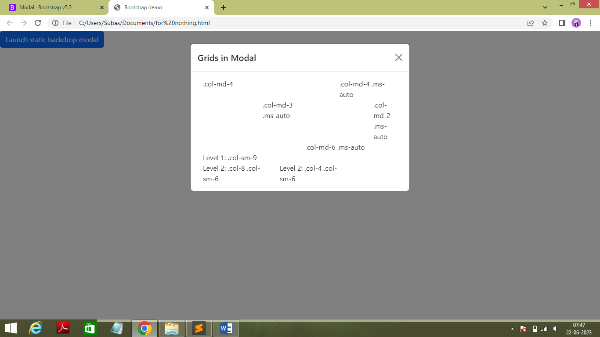

* Code :

<!doctype html>

<html lang="en">

<head>

<meta charset="utf-8">

<meta name="viewport" content="width=device-width, initial-scale=1">

<title>Bootstrap demo</title>

<link href="https://cdn.jsdelivr.net/npm/bootstrap@5.3.0/dist/css/bootstrap.min.css" rel="stylesheet" integrity="sha384-9ndCyUaIbzAi2FUVXJi0CjmCapSmO7SnpJef0486qhLnuZ2cdeRhO02iuK6FUUVM" crossorigin="anonymous">

</head>

<body>

<!-- Button trigger modal -->

<button type="button" class="btn btn-primary" data-bs-toggle="modal" data-bs-target="#staticBackdrop">

Launch static backdrop modal

</button>

<!-- Modal -->

<div class="modal fade" id="staticBackdrop" data-bs-backdrop="static" data-bs-keyboard="false" tabindex="-1" aria-labelledby="staticBackdropLabel" aria-hidden="true">

<div class="modal-dialog">

<div class="modal-content">

<div class="modal-header">

<h1 class="modal-title fs-5" id="staticBackdropLabel">Grids in Modal</h1>

<button type="button" class="btn-close" data-bs-dismiss="modal" aria-label="Close"></button>

</div>

<div class="modal-body">

<div class="container-fluid">

<div class="row">

<div class="col-md-4">.col-md-4</div>

<div class="col-md-4 ms-auto">.col-md-4 .ms-auto</div>

</div>

<div class="row">

<div class="col-md-3 ms-auto">.col-md-3 .ms-auto</div>

<div class="col-md-2 ms-auto">.col-md-2 .ms-auto</div>

</div>

<div class="row">

<div class="col-md-6 ms-auto">.col-md-6 .ms-auto</div>

</div>

<div class="row">

<div class="col-sm-9">

Level 1: .col-sm-9

<div class="row">

<div class="col-8 col-sm-6">

Level 2: .col-8 .col-sm-6

</div>

<div class="col-4 col-sm-6">

Level 2: .col-4 .col-sm-6

</div>

</div>

</div>

</div>

</div>

</div>

<script src="https://cdn.jsdelivr.net/npm/bootstrap@5.3.0/dist/js/bootstrap.bundle.min.js" integrity="sha384-geWF76RCwLtnZ8qwWowPQNguL3RmwHVBC9FhGdlKrxdiJJigb/j/68SIy3Te4Bkz" crossorigin="anonymous"></script>

<script >

const toastTrigger = document.getElementById('liveToastBtn')

const toastLiveExample = document.getElementById('liveToast')

if (toastTrigger) {

const toastBootstrap = bootstrap.Toast.getOrCreateInstance(toastLiveExample)

toastTrigger.addEventListener('click', () => {

toastBootstrap.show()

})

}

</script>

</body>

</html>

* + - * **Toogle Between Modals**
* Output :

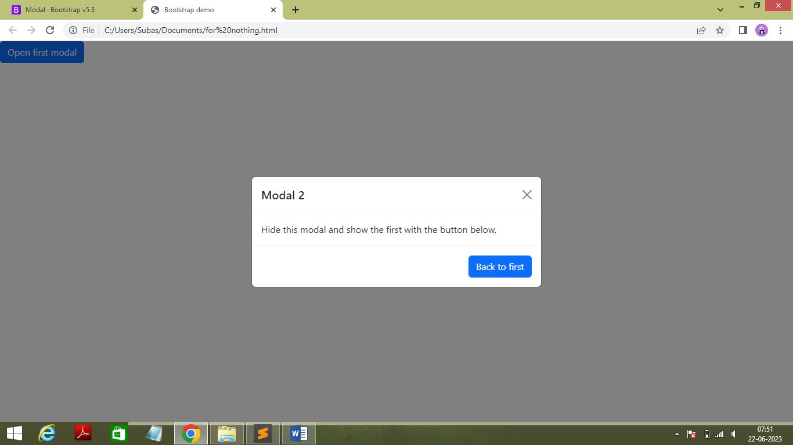

* Code :

<!doctype html>

<html lang="en">

<head>

<meta charset="utf-8">

<meta name="viewport" content="width=device-width, initial-scale=1">

<title>Bootstrap demo</title>

<link href="https://cdn.jsdelivr.net/npm/bootstrap@5.3.0/dist/css/bootstrap.min.css" rel="stylesheet" integrity="sha384-9ndCyUaIbzAi2FUVXJi0CjmCapSmO7SnpJef0486qhLnuZ2cdeRhO02iuK6FUUVM" crossorigin="anonymous">

</head>

<body>

<div class="modal fade" id="exampleModalToggle" aria-hidden="true" aria-labelledby="exampleModalToggleLabel" tabindex="-1">

<div class="modal-dialog modal-dialog-centered">

<div class="modal-content">

<div class="modal-header">

<h1 class="modal-title fs-5" id="exampleModalToggleLabel">Modal 1</h1>

<button type="button" class="btn-close" data-bs-dismiss="modal" aria-label="Close"></button>

</div>

<div class="modal-body">

Show a second modal and hide this one with the button below.

</div>

<div class="modal-footer">

<button class="btn btn-primary" data-bs-target="#exampleModalToggle2" data-bs-toggle="modal">Open second modal</button>

</div>

</div>

</div>

</div>

<div class="modal fade" id="exampleModalToggle2" aria-hidden="true" aria-labelledby="exampleModalToggleLabel2" tabindex="-1">

<div class="modal-dialog modal-dialog-centered">

<div class="modal-content">

<div class="modal-header">

<h1 class="modal-title fs-5" id="exampleModalToggleLabel2">Modal 2</h1>

<button type="button" class="btn-close" data-bs-dismiss="modal" aria-label="Close"></button>

</div>

<div class="modal-body">

Hide this modal and show the first with the button below.

</div>

<div class="modal-footer">

<button class="btn btn-primary" data-bs-target="#exampleModalToggle" data-bs-toggle="modal">Back to first</button>

</div>

</div>

</div>

</div>

<button class="btn btn-primary" data-bs-target="#exampleModalToggle" data-bs-toggle="modal">Open first modal</button>

<script src="https://cdn.jsdelivr.net/npm/bootstrap@5.3.0/dist/js/bootstrap.bundle.min.js" integrity="sha384-geWF76RCwLtnZ8qwWowPQNguL3RmwHVBC9FhGdlKrxdiJJigb/j/68SIy3Te4Bkz" crossorigin="anonymous"></script>

<script >

const toastTrigger = document.getElementById('liveToastBtn')

const toastLiveExample = document.getElementById('liveToast')

if (toastTrigger) {

const toastBootstrap = bootstrap.Toast.getOrCreateInstance(toastLiveExample)

toastTrigger.addEventListener('click', () => {

toastBootstrap.show()

})

}

</script>

</body>

</html>

* **Progress Bar** 
  + - * **Example of Progress Bar**
* Output :

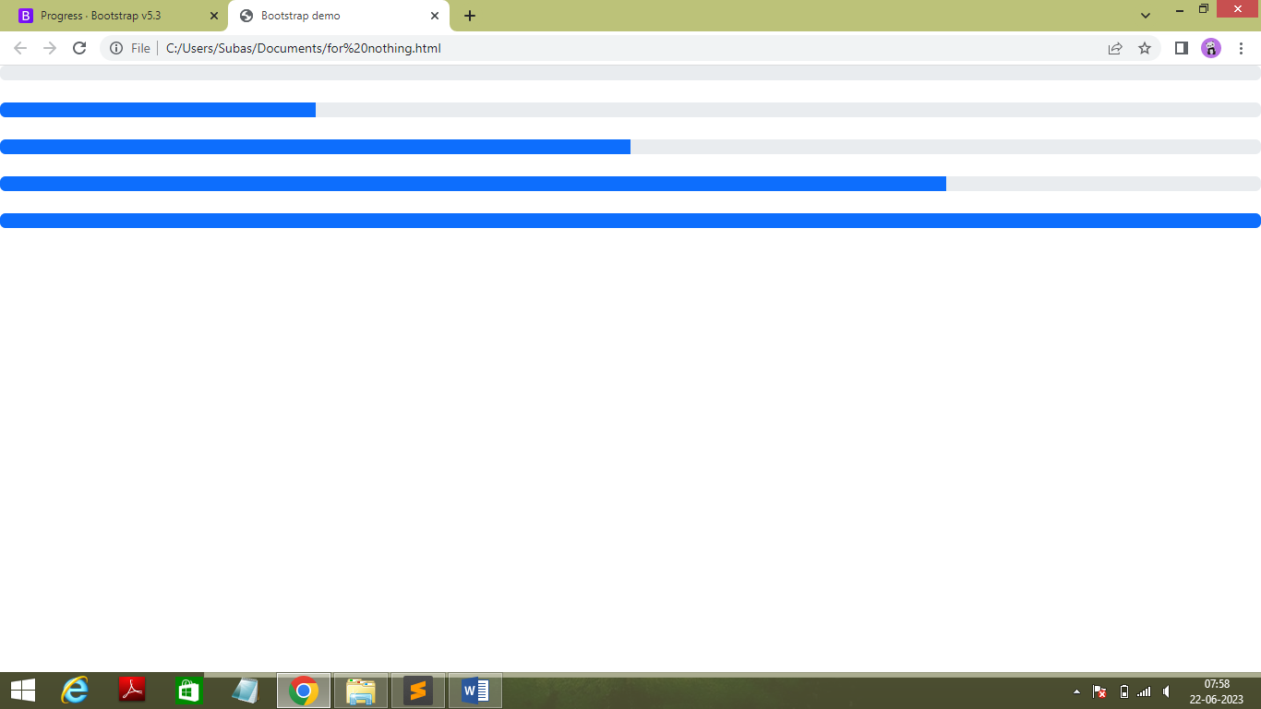

* Code :

<!doctype html>

<html lang="en">

<head>

<meta charset="utf-8">

<meta name="viewport" content="width=device-width, initial-scale=1">

<title>Bootstrap demo</title>

<link href="https://cdn.jsdelivr.net/npm/bootstrap@5.3.0/dist/css/bootstrap.min.css" rel="stylesheet" integrity="sha384-9ndCyUaIbzAi2FUVXJi0CjmCapSmO7SnpJef0486qhLnuZ2cdeRhO02iuK6FUUVM" crossorigin="anonymous">

</head>

<body>

<div class="progress" role="progressbar" aria-label="Basic example" aria-valuenow="0" aria-valuemin="0" aria-valuemax="100">

<div class="progress-bar" style="width: 0%"></div>

</div><br>

<div class="progress" role="progressbar" aria-label="Basic example" aria-valuenow="25" aria-valuemin="0" aria-valuemax="100">

<div class="progress-bar" style="width: 25%"></div>

</div><br>

<div class="progress" role="progressbar" aria-label="Basic example" aria-valuenow="50" aria-valuemin="0" aria-valuemax="100">

<div class="progress-bar" style="width: 50%"></div>

</div><br>

<div class="progress" role="progressbar" aria-label="Basic example" aria-valuenow="75" aria-valuemin="0" aria-valuemax="100">

<div class="progress-bar" style="width: 75%"></div>

</div><br>

<div class="progress" role="progressbar" aria-label="Basic example" aria-valuenow="100" aria-valuemin="0" aria-valuemax="100">

<div class="progress-bar" style="width: 100%"></div>

</div>

<script src="https://cdn.jsdelivr.net/npm/bootstrap@5.3.0/dist/js/bootstrap.bundle.min.js" integrity="sha384-geWF76RCwLtnZ8qwWowPQNguL3RmwHVBC9FhGdlKrxdiJJigb/j/68SIy3Te4Bkz" crossorigin="anonymous"></script>

<script >

const toastTrigger = document.getElementById('liveToastBtn')

const toastLiveExample = document.getElementById('liveToast')

if (toastTrigger) {

const toastBootstrap = bootstrap.Toast.getOrCreateInstance(toastLiveExample)

toastTrigger.addEventListener('click', () => {

toastBootstrap.show()

})

}

</script>

</body>

</html>

* + - * **Labels inside the Progress bar**
* Output :

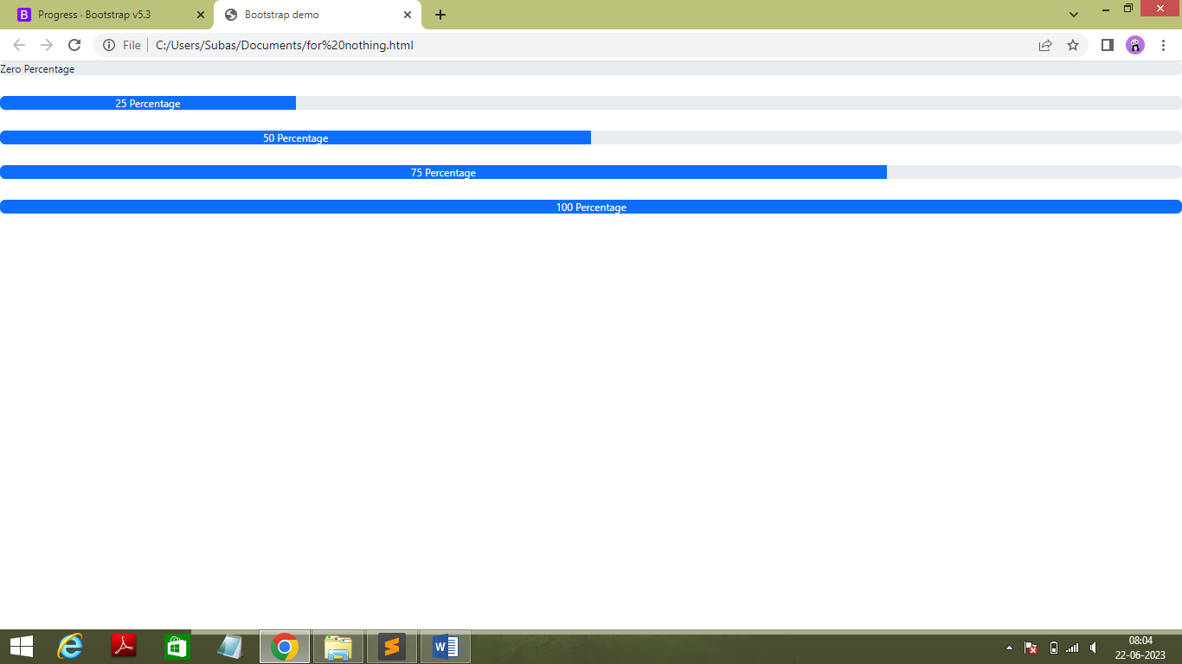

* Code :

<!doctype html>

<html lang="en">

<head>

<meta charset="utf-8">

<meta name="viewport" content="width=device-width, initial-scale=1">

<title>Bootstrap demo</title>

<link href="https://cdn.jsdelivr.net/npm/bootstrap@5.3.0/dist/css/bootstrap.min.css" rel="stylesheet" integrity="sha384-9ndCyUaIbzAi2FUVXJi0CjmCapSmO7SnpJef0486qhLnuZ2cdeRhO02iuK6FUUVM" crossorigin="anonymous">

</head>

<body>

<div class="progress" role="progressbar" aria-label="Basic example" aria-valuenow="0" aria-valuemin="0" aria-valuemax="100">

<div class="progress-bar overflow-visible text-dark" style="width: 0%">Zero Percentage</div>

</div><br>

<div class="progress" role="progressbar" aria-label="Basic example" aria-valuenow="25" aria-valuemin="0" aria-valuemax="100">

<div class="progress-bar" style="width: 25%">25 Percentage</div>

</div><br>

<div class="progress" role="progressbar" aria-label="Basic example" aria-valuenow="50" aria-valuemin="0" aria-valuemax="100">

<div class="progress-bar" style="width: 50%">50 Percentage</div>

</div><br>

<div class="progress" role="progressbar" aria-label="Basic example" aria-valuenow="75" aria-valuemin="0" aria-valuemax="100">

<div class="progress-bar" style="width: 75%">75 Percentage</div>

</div><br>

<div class="progress" role="progressbar" aria-label="Basic example" aria-valuenow="100" aria-valuemin="0" aria-valuemax="100">

<div class="progress-bar" style="width: 100%">100 Percentage</div>

</div>

<script src="https://cdn.jsdelivr.net/npm/bootstrap@5.3.0/dist/js/bootstrap.bundle.min.js" integrity="sha384-geWF76RCwLtnZ8qwWowPQNguL3RmwHVBC9FhGdlKrxdiJJigb/j/68SIy3Te4Bkz" crossorigin="anonymous"></script>

<script >

const toastTrigger = document.getElementById('liveToastBtn')

const toastLiveExample = document.getElementById('liveToast')

if (toastTrigger) {

const toastBootstrap = bootstrap.Toast.getOrCreateInstance(toastLiveExample)

toastTrigger.addEventListener('click', () => {

toastBootstrap.show()

})

}

</script>

</body>

</html>

* + - * **Background Color**
* Output :

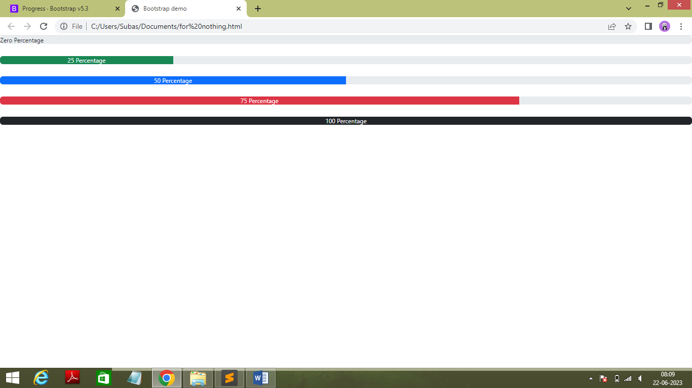

* Code :

<!doctype html>

<html lang="en">

<head>

<meta charset="utf-8">

<meta name="viewport" content="width=device-width, initial-scale=1">

<title>Bootstrap demo</title>

<link href="https://cdn.jsdelivr.net/npm/bootstrap@5.3.0/dist/css/bootstrap.min.css" rel="stylesheet" integrity="sha384-9ndCyUaIbzAi2FUVXJi0CjmCapSmO7SnpJef0486qhLnuZ2cdeRhO02iuK6FUUVM" crossorigin="anonymous">

</head>

<body>

<div class="progress" role="progressbar" aria-label="Basic example" aria-valuenow="0" aria-valuemin="0" aria-valuemax="100">

<div class="progress-bar overflow-visible text-dark" style="width: 0%">Zero Percentage</div>

</div><br>

<div class="progress" role="progressbar" aria-label="Basic example" aria-valuenow="25" aria-valuemin="0" aria-valuemax="100">

<div class="progress-bar bg-success" style="width: 25%">25 Percentage</div>

</div><br>

<div class="progress" role="progressbar" aria-label="Basic example" aria-valuenow="50" aria-valuemin="0" aria-valuemax="100">

<div class="progress-bar bg-primary" style="width: 50%">50 Percentage</div>

</div><br>

<div class="progress" role="progressbar" aria-label="Basic example" aria-valuenow="75" aria-valuemin="0" aria-valuemax="100">

<div class="progress-bar bg-danger" style="width: 75%">75 Percentage</div>

</div><br>

<div class="progress" role="progressbar" aria-label="Basic example" aria-valuenow="100" aria-valuemin="0" aria-valuemax="100">

<div class="progress-bar bg-dark" style="width: 100%">100 Percentage</div>

</div>

<script src="https://cdn.jsdelivr.net/npm/bootstrap@5.3.0/dist/js/bootstrap.bundle.min.js" integrity="sha384-geWF76RCwLtnZ8qwWowPQNguL3RmwHVBC9FhGdlKrxdiJJigb/j/68SIy3Te4Bkz" crossorigin="anonymous"></script>

<script >

const toastTrigger = document.getElementById('liveToastBtn')

const toastLiveExample = document.getElementById('liveToast')

if (toastTrigger) {

const toastBootstrap = bootstrap.Toast.getOrCreateInstance(toastLiveExample)

toastTrigger.addEventListener('click', () => {

toastBootstrap.show()

})

}

</script>

</body>

</html>

* + - * **Animated Strips**
* Output :

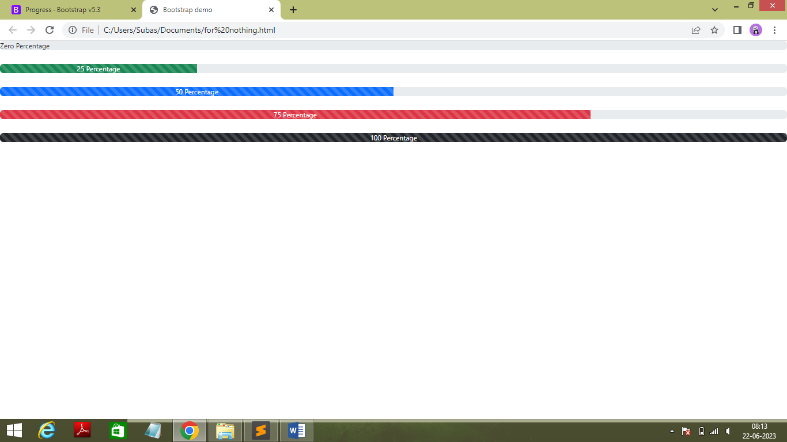

* Code :

<!doctype html>

<html lang="en">

<head>

<meta charset="utf-8">

<meta name="viewport" content="width=device-width, initial-scale=1">

<title>Bootstrap demo</title>

<link href="https://cdn.jsdelivr.net/npm/bootstrap@5.3.0/dist/css/bootstrap.min.css" rel="stylesheet" integrity="sha384-9ndCyUaIbzAi2FUVXJi0CjmCapSmO7SnpJef0486qhLnuZ2cdeRhO02iuK6FUUVM" crossorigin="anonymous">

</head>

<body>

<div class="progress" role="progressbar" aria-label="Basic example" aria-valuenow="0" aria-valuemin="0" aria-valuemax="100">

<div class="progress-bar overflow-visible text-dark" style="width: 0%">Zero Percentage</div>

</div><br>

<div class="progress" role="progressbar" aria-label="Basic example" aria-valuenow="25" aria-valuemin="0" aria-valuemax="100">

<div class="progress-bar progress-bar-striped progress-bar-animated bg-success" style="width: 25%">25 Percentage</div>

</div><br>

<div class="progress" role="progressbar" aria-label="Basic example" aria-valuenow="50" aria-valuemin="0" aria-valuemax="100">

<div class="progress-bar progress-bar-striped progress-bar-animated bg-primary" style="width: 50%">50 Percentage</div>

</div><br>

<div class="progress" role="progressbar" aria-label="Basic example" aria-valuenow="75" aria-valuemin="0" aria-valuemax="100">

<div class="progress-bar progress-bar-striped progress-bar-animated bg-danger" style="width: 75%">75 Percentage</div>

</div><br>

<div class="progress" role="progressbar" aria-label="Basic example" aria-valuenow="100" aria-valuemin="0" aria-valuemax="100">

<div class="progress-bar progress-bar-striped progress-bar-animated bg-dark" style="width: 100%">100 Percentage</div>

</div>

<script src="https://cdn.jsdelivr.net/npm/bootstrap@5.3.0/dist/js/bootstrap.bundle.min.js" integrity="sha384-geWF76RCwLtnZ8qwWowPQNguL3RmwHVBC9FhGdlKrxdiJJigb/j/68SIy3Te4Bkz" crossorigin="anonymous"></script>

<script >

const toastTrigger = document.getElementById('liveToastBtn')

const toastLiveExample = document.getElementById('liveToast')

if (toastTrigger) {

const toastBootstrap = bootstrap.Toast.getOrCreateInstance(toastLiveExample)

toastTrigger.addEventListener('click', () => {

toastBootstrap.show()

})

}

</script>

</body>

</html>

* **Navbar**
  + - * **Example of Navbar**
* Output :

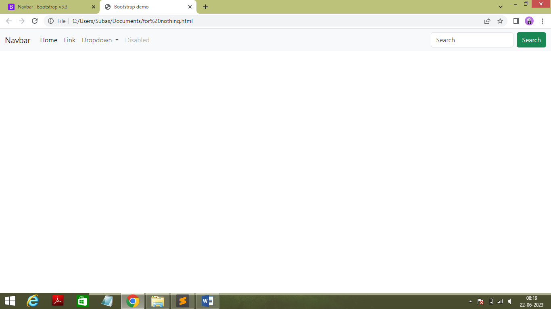

* Code :

<!doctype html>

<html lang="en">

<head>

<meta charset="utf-8">

<meta name="viewport" content="width=device-width, initial-scale=1">

<title>Bootstrap demo</title>

<link href="https://cdn.jsdelivr.net/npm/bootstrap@5.3.0/dist/css/bootstrap.min.css" rel="stylesheet" integrity="sha384-9ndCyUaIbzAi2FUVXJi0CjmCapSmO7SnpJef0486qhLnuZ2cdeRhO02iuK6FUUVM" crossorigin="anonymous">

</head>

<body>

<nav class="navbar navbar-expand-lg bg-body-tertiary">

<div class="container-fluid">

<a class="navbar-brand" href="#">Navbar</a>

<button class="navbar-toggler" type="button" data-bs-toggle="collapse" data-bs-target="#navbarSupportedContent" aria-controls="navbarSupportedContent" aria-expanded="false" aria-label="Toggle navigation">

<span class="navbar-toggler-icon"></span>

</button>

<div class="collapse navbar-collapse" id="navbarSupportedContent">

<ul class="navbar-nav me-auto mb-2 mb-lg-0">

<li class="nav-item">

<a class="nav-link active" aria-current="page" href="#">Home</a>

</li>

<li class="nav-item">

<a class="nav-link" href="#">Link</a>

</li>

<li class="nav-item dropdown">

<a class="nav-link dropdown-toggle" href="#" role="button" data-bs-toggle="dropdown" aria-expanded="false">

Dropdown

</a>

<ul class="dropdown-menu">

<li><a class="dropdown-item" href="#">Action</a></li>

<li><a class="dropdown-item" href="#">Another action</a></li>

<li><hr class="dropdown-divider"></li>

<li><a class="dropdown-item" href="#">Something else here</a></li>

</ul>

</li>

<li class="nav-item">

<a class="nav-link disabled">Disabled</a>

</li>

</ul>

<form class="d-flex" role="search">

<input class="form-control me-2" type="search" placeholder="Search" aria-label="Search">

<button class="btn btn-outline-success" type="submit">Search</button>

</form>

</div>

</div>

</nav>

<script src="https://cdn.jsdelivr.net/npm/bootstrap@5.3.0/dist/js/bootstrap.bundle.min.js" integrity="sha384-geWF76RCwLtnZ8qwWowPQNguL3RmwHVBC9FhGdlKrxdiJJigb/j/68SIy3Te4Bkz" crossorigin="anonymous"></script>

<script >

const toastTrigger = document.getElementById('liveToastBtn')

const toastLiveExample = document.getElementById('liveToast')

if (toastTrigger) {

const toastBootstrap = bootstrap.Toast.getOrCreateInstance(toastLiveExample)

toastTrigger.addEventListener('click', () => {

toastBootstrap.show()

})

}

</script>

</body>

</html>

* + - * **Color Schemes**
* Output :

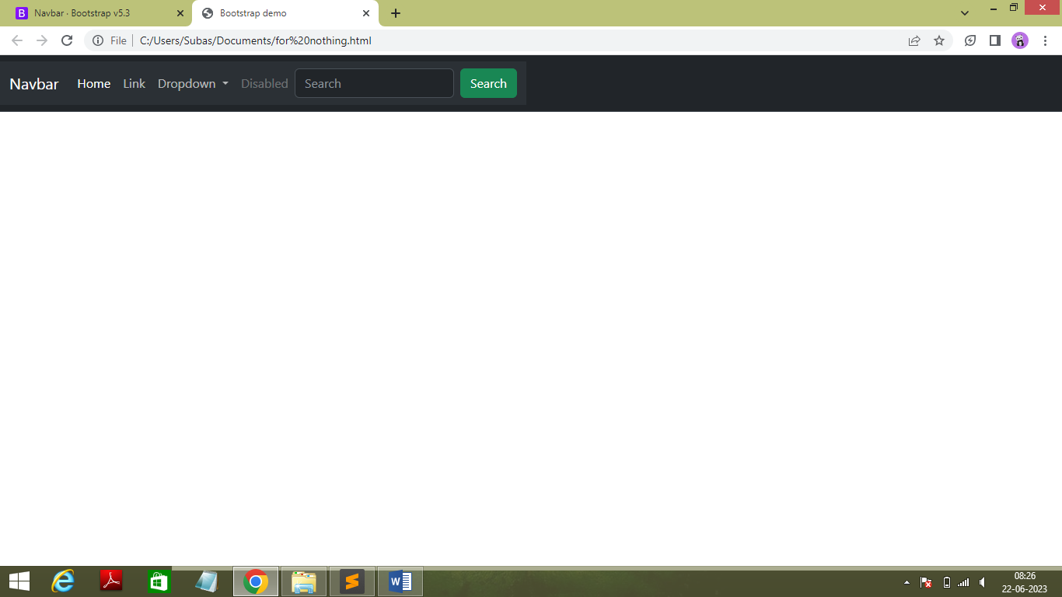

* Code :

<!doctype html>

<html lang="en">

<head>

<meta charset="utf-8">

<meta name="viewport" content="width=device-width, initial-scale=1">

<title>Bootstrap demo</title>

<link href="https://cdn.jsdelivr.net/npm/bootstrap@5.3.0/dist/css/bootstrap.min.css" rel="stylesheet" integrity="sha384-9ndCyUaIbzAi2FUVXJi0CjmCapSmO7SnpJef0486qhLnuZ2cdeRhO02iuK6FUUVM" crossorigin="anonymous">

</head>

<body>

<nav class="navbar bg-dark border-bottom border-bottom-dark" data-bs-theme="dark">

<nav class="navbar navbar-expand-lg bg-body-tertiary">

<div class="container-fluid">

<a class="navbar-brand" href="#">Navbar</a>

<button class="navbar-toggler" type="button" data-bs-toggle="collapse" data-bs-target="#navbarSupportedContent" aria-controls="navbarSupportedContent" aria-expanded="false" aria-label="Toggle navigation">

<span class="navbar-toggler-icon"></span>

</button>

<div class="collapse navbar-collapse" id="navbarSupportedContent">

<ul class="navbar-nav me-auto mb-2 mb-lg-0">

<li class="nav-item">

<a class="nav-link active" aria-current="page" href="#">Home</a>

</li>

<li class="nav-item">

<a class="nav-link" href="#">Link</a>

</li>

<li class="nav-item dropdown">

<a class="nav-link dropdown-toggle" href="#" role="button" data-bs-toggle="dropdown" aria-expanded="false">

Dropdown

</a>

<ul class="dropdown-menu">

<li><a class="dropdown-item" href="#">Action</a></li>

<li><a class="dropdown-item" href="#">Another action</a></li>

<li><hr class="dropdown-divider"></li>

<li><a class="dropdown-item" href="#">Something else here</a></li>

</ul>

</li>

<li class="nav-item">

<a class="nav-link disabled">Disabled</a>

</li>

</ul>

<form class="d-flex" role="search">

<input class="form-control me-2" type="search" placeholder="Search" aria-label="Search">

<button class="btn btn-outline-success" type="submit">Search</button>

</form>

</div>

</div>

</nav>

</nav><br>

<script src="https://cdn.jsdelivr.net/npm/bootstrap@5.3.0/dist/js/bootstrap.bundle.min.js" integrity="sha384-geWF76RCwLtnZ8qwWowPQNguL3RmwHVBC9FhGdlKrxdiJJigb/j/68SIy3Te4Bkz" crossorigin="anonymous"></script>

<script >

const toastTrigger = document.getElementById('liveToastBtn')

const toastLiveExample = document.getElementById('liveToast')

if (toastTrigger) {

const toastBootstrap = bootstrap.Toast.getOrCreateInstance(toastLiveExample)

toastTrigger.addEventListener('click', () => {

toastBootstrap.show()

})

}

</script>

</body>

</html>

* **Spinner**
  + - * **Color Schemes**
* Output :

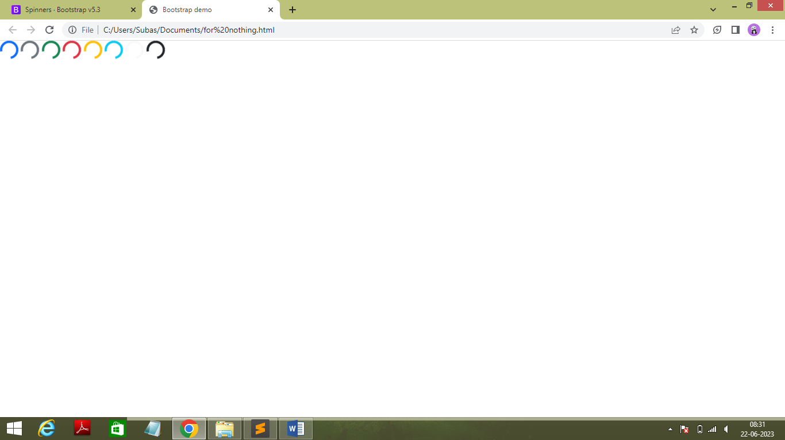

* Code :

<!doctype html>

<html lang="en">

<head>

<meta charset="utf-8">

<meta name="viewport" content="width=device-width, initial-scale=1">

<title>Bootstrap demo</title>

<link href="https://cdn.jsdelivr.net/npm/bootstrap@5.3.0/dist/css/bootstrap.min.css" rel="stylesheet" integrity="sha384-9ndCyUaIbzAi2FUVXJi0CjmCapSmO7SnpJef0486qhLnuZ2cdeRhO02iuK6FUUVM" crossorigin="anonymous">

</head>

<body>

<div class="spinner-border text-primary" role="status">

<span class="visually-hidden">Loading...</span>

</div>

<div class="spinner-border text-secondary" role="status">

<span class="visually-hidden">Loading...</span>

</div>

<div class="spinner-border text-success" role="status">

<span class="visually-hidden">Loading...</span>

</div>

<div class="spinner-border text-danger" role="status">

<span class="visually-hidden">Loading...</span>

</div>

<div class="spinner-border text-warning" role="status">

<span class="visually-hidden">Loading...</span>

</div>

<div class="spinner-border text-info" role="status">

<span class="visually-hidden">Loading...</span>

</div>

<div class="spinner-border text-light" role="status">

<span class="visually-hidden">Loading...</span>

</div>

<div class="spinner-border text-dark" role="status">

<span class="visually-hidden">Loading...</span>

</div>

<script src="https://cdn.jsdelivr.net/npm/bootstrap@5.3.0/dist/js/bootstrap.bundle.min.js" integrity="sha384-geWF76RCwLtnZ8qwWowPQNguL3RmwHVBC9FhGdlKrxdiJJigb/j/68SIy3Te4Bkz" crossorigin="anonymous"></script>

<script >

const toastTrigger = document.getElementById('liveToastBtn')

const toastLiveExample = document.getElementById('liveToast')

if (toastTrigger) {

const toastBootstrap = bootstrap.Toast.getOrCreateInstance(toastLiveExample)

toastTrigger.addEventListener('click', () => {

toastBootstrap.show()

})

}

</script>

</body>

</html>

* + - * **Growing Spinner**
* Output :

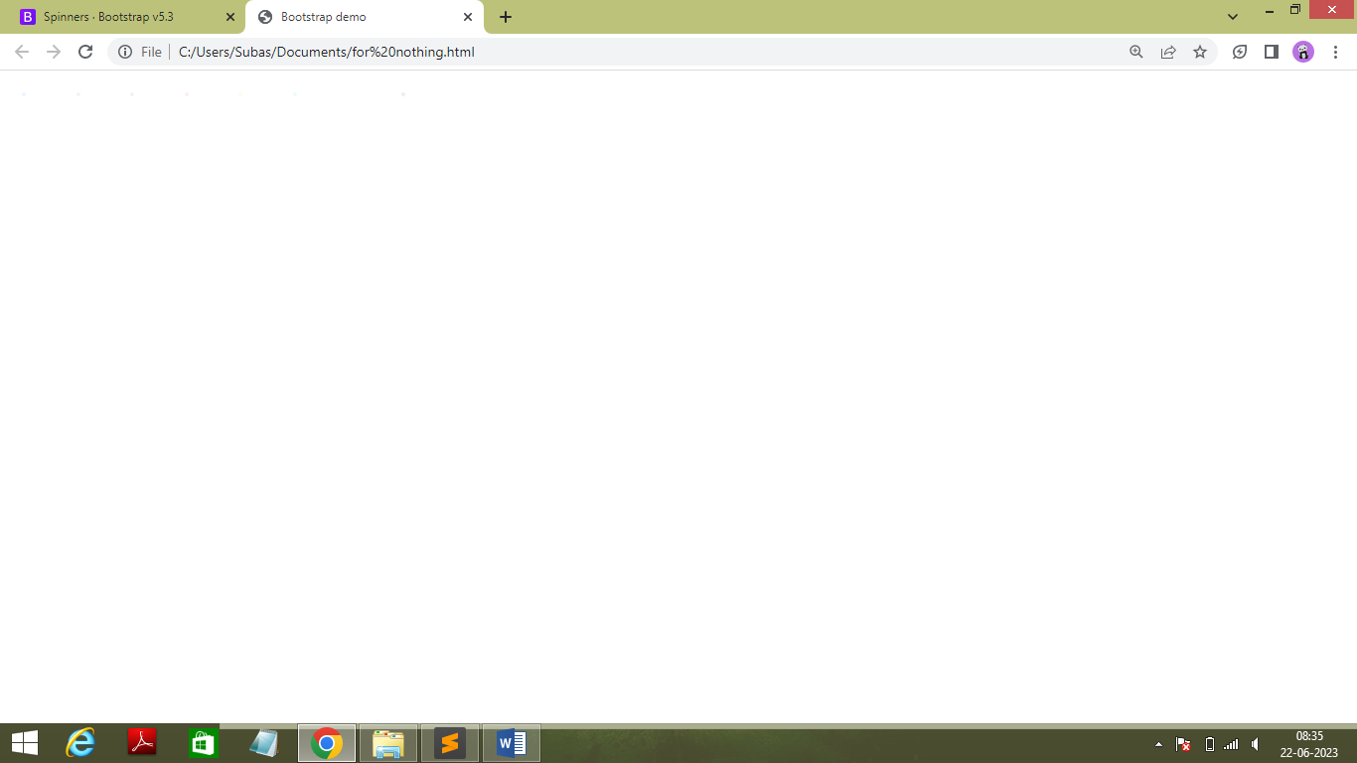

* Code :

<!doctype html>

<html lang="en">

<head>

<meta charset="utf-8">

<meta name="viewport" content="width=device-width, initial-scale=1">

<title>Bootstrap demo</title>

<link href="https://cdn.jsdelivr.net/npm/bootstrap@5.3.0/dist/css/bootstrap.min.css" rel="stylesheet" integrity="sha384-9ndCyUaIbzAi2FUVXJi0CjmCapSmO7SnpJef0486qhLnuZ2cdeRhO02iuK6FUUVM" crossorigin="anonymous">

</head>

<body>

<div class="spinner-grow text-primary" role="status">

<span class="visually-hidden">Loading...</span>

</div>

<div class="spinner-grow text-secondary" role="status">

<span class="visually-hidden">Loading...</span>

</div>

<div class="spinner-grow text-success" role="status">

<span class="visually-hidden">Loading...</span>

</div>

<div class="spinner-grow text-danger" role="status">

<span class="visually-hidden">Loading...</span>

</div>

<div class="spinner-grow text-warning" role="status">

<span class="visually-hidden">Loading...</span>

</div>

<div class="spinner-grow text-info" role="status">

<span class="visually-hidden">Loading...</span>

</div>

<div class="spinner-grow text-light" role="status">

<span class="visually-hidden">Loading...</span>

</div>

<div class="spinner-grow text-dark" role="status">

<span class="visually-hidden">Loading...</span>

</div>

<script src="https://cdn.jsdelivr.net/npm/bootstrap@5.3.0/dist/js/bootstrap.bundle.min.js" integrity="sha384-geWF76RCwLtnZ8qwWowPQNguL3RmwHVBC9FhGdlKrxdiJJigb/j/68SIy3Te4Bkz" crossorigin="anonymous"></script>

<script >

const toastTrigger = document.getElementById('liveToastBtn')

const toastLiveExample = document.getElementById('liveToast')

if (toastTrigger) {

const toastBootstrap = bootstrap.Toast.getOrCreateInstance(toastLiveExample)

toastTrigger.addEventListener('click', () => {

toastBootstrap.show()

})

}

</script>

</body>

</html>

* + - * **Buttons**
* Output :

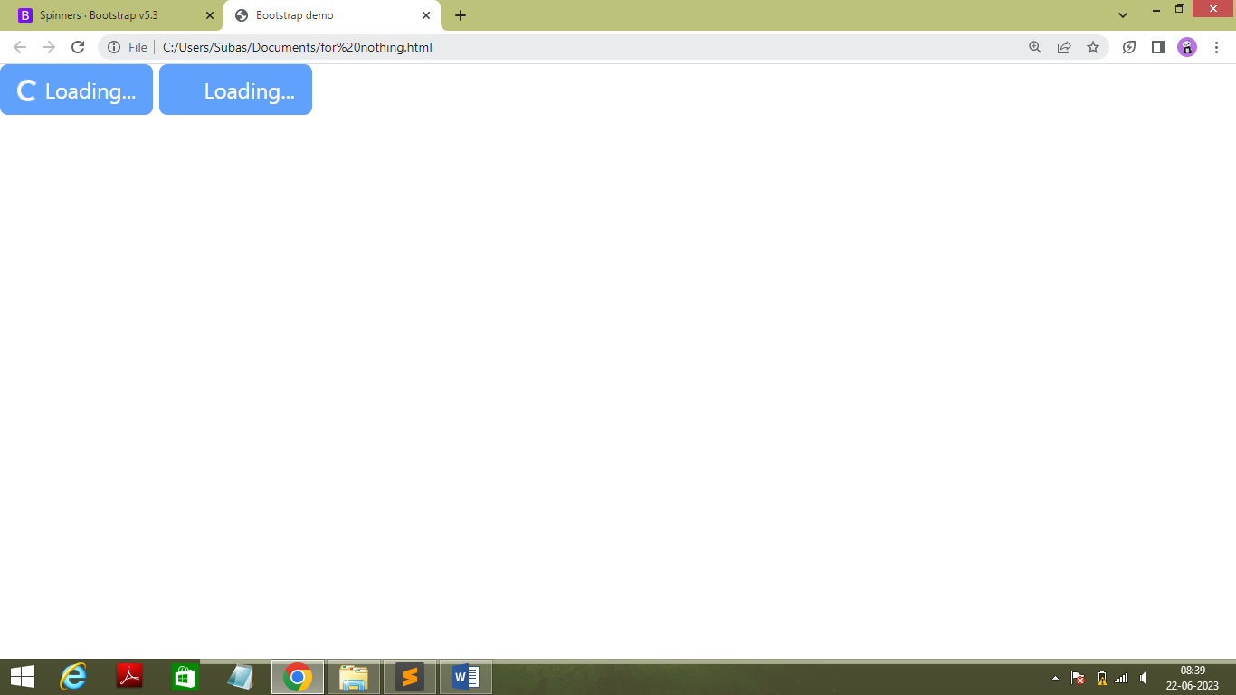

* Code :

<!doctype html>

<html lang="en">

<head>

<meta charset="utf-8">

<meta name="viewport" content="width=device-width, initial-scale=1">

<title>Bootstrap demo</title>

<link href="https://cdn.jsdelivr.net/npm/bootstrap@5.3.0/dist/css/bootstrap.min.css" rel="stylesheet" integrity="sha384-9ndCyUaIbzAi2FUVXJi0CjmCapSmO7SnpJef0486qhLnuZ2cdeRhO02iuK6FUUVM" crossorigin="anonymous">

</head>

<body>

<button class="btn btn-primary" type="button" disabled>

<span class="spinner-border spinner-border-sm" role="status" aria-hidden="true"></span>

Loading...

</button>

<button class="btn btn-primary" type="button" disabled>

<span class="spinner-grow spinner-grow-sm" role="status" aria-hidden="true"></span>

Loading...

</button>

<script src="https://cdn.jsdelivr.net/npm/bootstrap@5.3.0/dist/js/bootstrap.bundle.min.js" integrity="sha384-geWF76RCwLtnZ8qwWowPQNguL3RmwHVBC9FhGdlKrxdiJJigb/j/68SIy3Te4Bkz" crossorigin="anonymous"></script>

<script >

const toastTrigger = document.getElementById('liveToastBtn')

const toastLiveExample = document.getElementById('liveToast')

if (toastTrigger) {

const toastBootstrap = bootstrap.Toast.getOrCreateInstance(toastLiveExample)

toastTrigger.addEventListener('click', () => {

toastBootstrap.show()

})

}

</script>

</body>

</html>